Recommended books and other resources – from Curriculum Days 2015

The Junkroom Band’s – Gig Goes Global – written by Joy Berry
http://www.kidsforglobalpeace.com/userAssets/file/KFGP-GigGoesGlobal.pdf

Play it Fair! Human Rights Education Toolkit for Children
https://equitas.org/wp-content/uploads/2010/11/2008-Play-it-Fair-Toolkit_En.pdf

Kindness Day

http://static1.squarespace.com/static/522f7cdbe4b056ca5e8127f6/t/5550aae6e4b063a030345c24/1431349990739/Kindness+Day+Resource+Pack.pdf

Kids4sermons : http://www.sermons4kids.com

Presenting the New Testament – Maurice Ryan (Pauline Books & Media)

A manual of teaching activities, commentary and blackline masters.

Maurice Ryan: Learning Links to The Prophets Learning Links to Parables & Miracles

Learning Links to Creation Learning Links to The Gospels

Bein’ with You This Way – W Nikola-Lisa

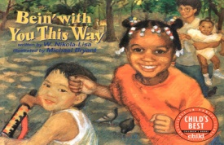
In a rap-style prose poem, expressively illustrated in coloured pencil, a racially mixed group of children enjoying a sunny day at the playground discovers the virtues of racial diversity and, at the same time, the basic identity of all human beings.

Home at Last – Susan Middleton Elya

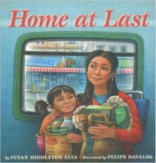
Ana Patino is adjusting well to her new life in the United States, but her mother is having a difficult time because she doesn't speak English. When Ana's baby brother falls ill, Mama tries to get help, but no one can understand her. Now convinced of the need to learn the native language, Mama agrees to take English lessons. As her knowledge of the English grows, so does her sense of confidence and belonging.

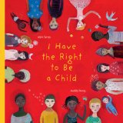
I Have the Right to be a Child – Alain Serres

A young narrator describes what it means to be a child with rights-from the right to food, water and shelter, to the right to go to school, to the right to be free from violence, to the right to breathe clean air, and much more. The book emphasizes that these rights belong to every child on the planet, whether they are “black or white, small or big, rich or poor, born here or somewhere else.” It also makes evident that knowing and talking about these rights are the first steps toward making sure that they are respected.
Street Children: Real Stories from Across the World (PB) – Anthony Robinson
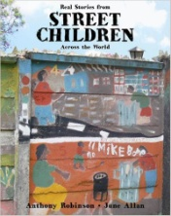
This sensitive portrayal tells the real-life stories of six courageous children and their families who live and work on the streets in Zimbabwe, Mozambique and Guatemala. These resourceful, resilient and optimistic children and families talk about their pasts, their present lives and their hopes for the future.
Images of God for Young Children – Marie-Helene Delval
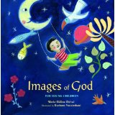
The Bible describes God in many different ways: God is light; God is joy; God is wisdom. God is the beauty that fills the earth and the rock we stand on, the promises we live by and the fire that purifies us. This volume offers a collection of these images, presented in simple language that young readers can easily understand. This book's bright artwork and lyrical text, explores how, even though we cannot see or touch God, we can still discover him in our world.
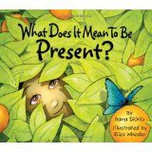
What Does it Mean to be Present - Rana DiOrio
This refreshing, vibrant picture book engages all of the senses to demonstrate the myriad of ways a child can seize the moment. The story sparks meaningful discussions about the important gift of appreciation, giving children and adults alike the opportunity to live more fully and richly
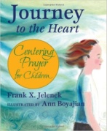
Journey to the Heart : Centering Prayer for Children – Frank X Jelenek
Centering prayer is a way of opening our whole being to God, beyond thoughts, words and emotions. It is simple and practical—a way of preparing heart and mind to receive the gift of intimate relationship with God. Jesus said, “When you pray, go to your inner room, close the door, and pray to your Father in secret. And your Father who sees in secret will reward you.” (Matthew 6:6)
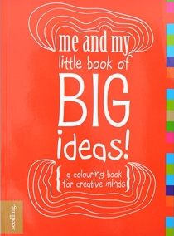  Me and My little book of Big Ideas – Seedling New Zealand Ltd  60 pages of colouring book for you to do it your way – invent machines, make delicious treats, draw treasure maps, go on holiday! The world is ready for your ideas | Each Kindness – Jacqueline Addams  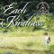  With its powerful anti-bullying message and striking art, it will resonate with readers long after they've put it down.

Playtime (Oxfam around the World) – Kate Petty  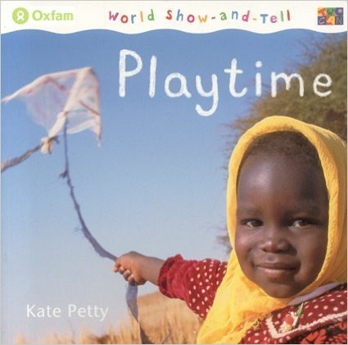  These sweet photographic works explore the similarities and differences in the ways children around the globe live and play. Each book ends with a map that shows where in the world each child lives. |  | Hair (Oxfam around the World) – Kate Petty  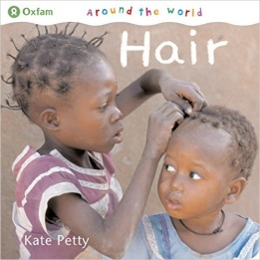  We wear our hair in lots of different ways. Sometimes it is to keep cool. Sometimes it's to look nice for a special occasion. This series aims to draw parallels between children from many different cultures.
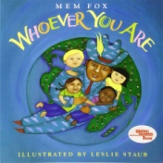
Whoever You Are - Mem Fox - Leslie Straub’s innovative, colorful, folk art–style oil paintings of children from all corners of the globe are bordered with photographs of hand-carved, bejeweled frames—and they all reflect Fox’s message that no matter where we come from, within our hearts “Joys are the same, / and love is the same. / Pain is the same, / and blood is the same.”
The Hurt – Teddi Doleski  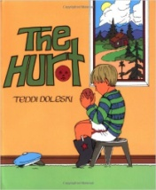  A children's story of a boy whose feelings get hurt when his friend calls him a name. A simple story with a moral/behavioral message | The Short and Incredibly Happy Life of Riley – Colin Thompson  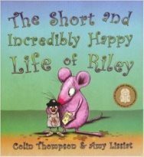  Human beings live for quite a long time and for a lot of that time we are not happy. We want to be taller, shorter, fatter, thinner, older and younger. We want our straight hair to be curly, our curly hair to be straight and our brown eyes to be blue.
Spoon - Krouse Rosenthal
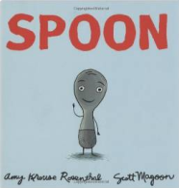
He's always been a happy little utensil. But lately, he feels like life as a spoon just isn't cutting it. He thinks Fork, Knife, and The Chopsticks all have it so much better than him. But do they? And what do they think about Spoon? A book for all ages, Spoon serves as a gentle reminder to celebrate what makes us each special.

