Year 1 – Communion of Saints - Mary | Year 2 – Communion of Saints – Saints and Inspiring People | Year 3– Communion of Saints – Life, Death and Christian Hope
As a Church on of the ways we honour Mary, the greatest of the Saints, is as the Mother of Jesus. We reflect on how Mary’s holiness was magnified by her encounters with the holiness and power, the Tapu and Mana of God. | Those officially declared by the Church to be saints because of their virtues, the holiness, the tapu and mana of their lives, are now with God. They act as models for the members of the Church on Earth, and are linked to them through prayer. The saintliness of ordinary people can also inspire others and lead them to God. | Suffering and death are part of life. Catholic beliefs about the resurrection of the body and life after death provide meaning and reason for hope. The rituals of Catholic funerals and tangi provide consolation for the bereaved. The Church encourages people to remember those who have died and pray for them.
- God had a special role for Mary as Jesus’ mother  (Lessons 1-3)  - Mary’s tapu and mana greatly increased when she became Jesus’ mother (Lessons 4-5) | - Certain qualities make people holy (Lessons 1-3).  - Saintliness in people can inspire others and lead them to God (Lessons 4-5).  - Ways to celebrate the lives of Saints (Lesson 6). | - Sad times are part of people’s lives and God helps us in these times (Lessons 1-3)  - Christians believe in life after death (Lessons 4-5)  - People have rituals to farewell loved ones and pray for them after they die (Lessons 6-7)
Year 4 – Communion of Saints - Choice | Communion of Saints  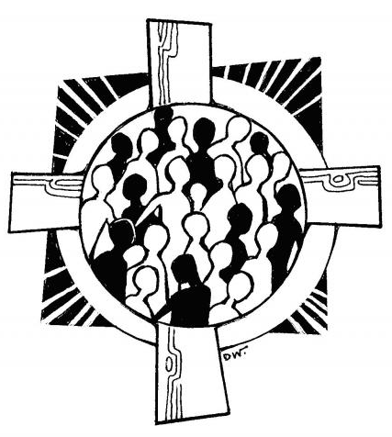 | Year 5 – Communion of Saints – Saints and Inspiring People
Our life journey; te wa, is a journey toward God. The choices we make on that journey have significance in terms of our final destination, our life after death. Traditionally the Church has spoken of life after death in terms of heaven, hell and purgatory. |  | Catholic s believe in the Communion of Saints; the unity of community of all the members of the Church, those now living, those who are with God in heaven, and those undergoing purification before entering into the fullness of life with God. The living may pray to the saints for their intercession and for those in purgatory. The living and the dead are all joined in praise of God
- Te Wa – the journey of life has a special meaning for Christians (Lessons 1-3)  - The choices that people make in their daily lives affect their lives after death (Lessons 4-7) |  | - Communion of Saints has a special meaning -- Te Kotahitanga o Te Hunga Tapu (Lesson 1)  - Because of their holiness and the way they lived their lives, Saints and Inspiring People are role models for people today (Lessons 2-3)  - The Church honours traditional and favourite Saints(L 4-5)
Year 6 – Communion of Saints - Mary | Year 7 – Communion of Saints - Choices | Year 8 – Communion of Saints – Life, Death and Christian Hope
From the New Testament we learn that Mary, the Mother of Jesus, is a model of faith and discipleship. Catholics honour Mary as the Mother of God, Mother of the Church and patroness of Aotearoa New Zealand. This honour is expressed in various forms of devotion to Mary. | With God’s gift of free will comes the responsibility to develop an informed conscience so that we may make life-giving choices for ourselves and others. This is particularly important in areas covered by the Church’s teaching on the sanctity of life. | The human person is both physical and spiritual. The Church has death and burial rituals for Catholic people in various cultures. With grief and loss there is Christian hope when we believe we will share in the fullness of the kingdom
- Stories in Scripture tell us of Mary’s faith journey (Lesson 1).  - Mary is a model for living and discipleship (Lesson 3)  - There are special places and special forms of devotion to Mary in the world (Lesson 5)  - Mary, the Mother of God is the Protector and Patron Saint of New Zealand (Lesson 6) | - God has given the gift of free will to people (Lesson 1)  - It is very important to have a well-informed conscience - hinengaro (Lessons 2-4).  - Everyday choices affect life after death(Lesson 5).  - Life is sacred and should be respected (Lessons 6-7). | - The human person is sacred and has an immortal soul (Lesson 1-2)  - Catholics believe that Christ will have a Second Coming – Te Tino Rangatiratanga (Lessons 3-4)  - Catholics follow certain burial rituals for those who have died (Lessons 5-6)  - Grief and loss is part of life but Christians look forward with hope (Lessons 7-8)

