The Liturgical Year
Year 1 | Year 2 | Year 3 | Year 4 | Year 5 | Year 6 | Year 7 | Year 8
Advent  - Mary and Joseph get ready for the birth of Jesus  - Mary’s Song of Praise  - Advent is a Time for Families-Whanau to prepare for Christmas  - Advent is celebrated in our school and our parish  Christmas  - The birth of Jesus  - The Christmas Story  Lent  - Lent is the season to get ready for Easter  - Getting ourselves ready for Easter  - Ash Wednesday is the first day of the season of Lent  Holy Week  - Make way for the King  - The Last Supper  - Jesus dies and rises  Easter  - Easter time is when Jesus rose from death  - Jesus showed himself to his friends the disciples after he had risen  - Jesus shares new life with the world  The Ascension  - Jesus returns to His Father in heaven  Pentecost  - The Holy Spirit – Te Wairua Tapu comes at Pentecost  The Assumption  - Mary is taken into heaven  All Saints Day  - The Feast of All Saints  All Souls Day  - Remembering and praying for All Souls | Advent  - Advent is a time of waiting  - Waiting with others  - Advent is a time for families to prepare for Christmas  Christmas  - Born in a stable  - Cribs tell the Christmas Story  Lent  - In Lent people try to follow Jesus more closely  - People can change to live more like Jesus lived  Holy Week  - Holy Week is a Holy Time  - Washing Feet  - Sad times – Glad times  Easter  - Easter is a season of joy because Jesus rose from the dead  - Recognising the Risen Jesus  - God’s people are Easter people  The Ascension  - The Church celebrates Jesus’ return to Heaven  Pentecost  - The Holy Spirit – Te Wairua Tapu comes in wind and fire  The Assumption  - Mary like Jesus, is taken to Heaven  All Saints Day  - The Feast of All Saints  All Souls Day  - Remembering and praying for those who have died | Advent  - The Advent wreath  - The Advent wreath in Aotearoa New Zealand  Christmas  - Jesus, God’s greatest gift  - Giving gifts  - Receiving gifts - taonga  Lent  - Lent is a season of change  - Changes in people  Holy Week  - Palm Sunday  - The Last Supper  - The death of Jesus  Easter  - What does the resurrection mean?  - Easter helps Christians to have hope  - People see signs of the new life of Easter  The Ascension  - Ascension is part of the Easter season  Pentecost  - Pentecost is the birthday of the Church  The Assumption  - The Assumption of Mary shows us our final destiny  All Saints Day  - The Feast of All Saints  All Souls Day  - All Souls Day | Advent  - Preparing the way for the coming of Jesus  - Preparing the way today  Christmas  - Carol singing – waiata  - Christmas trees  Lent  - Lent is a season for turning back to God through prayer  - Lent is a season for turning back to God through fasting and almsgiving  Holy Week  - Palm Sunday – Jesus is hailed as a King  - Good Friday – Jesus dies on a cross  - Celebrating Holy Week  Easter  - The Easter Story by 4 Writers  - The After Easter Stories  - What Easter – Te Aranga means to believers today  The Ascension  - Telling the Good News – Te Rongo Pai  Pentecost  - The mother of Jesus was present at Pentecost  The Assumption  - Mary of the Assumption is the Patron of Aotearoa New Zealand  All Saints Day  - The Feast of All Saints  All Souls Day  - All Souls Day | Advent  - The meaning of Advent  - The Jesse Tree  Christmas  - Making room for Christ in Christmas  - Christmas is a Holy Day of Obligation  Lent  - Lent begins on Ash Wednesday  - Lent – a time to repent and do penance  - Lent – growing in friendship with God through prayer - karakia  Holy Week  - Holy Week begins with the liturgy of Passion Sunday  - The Church celebrates Holy Thursday  - Celebrating the Good Friday liturgy  Easter  - Easter is the greatest feast in the Liturgical Year – Te Tau me ona Ritenga Tapu  - Meeting the risen Jesus today  The Ascension  - The Feast of the Ascension  Pentecost  - Pentecost – the spirit changes the Apostles  The Assumption  - The Feast o f the Assumption  All Saints Day  - The Feast of All Saints  All Souls Day  - All Souls Day | Advent  - The people of Advent  - The people who prepared the way for the Messiah  Christmas  - Christmas throughout the world  - Celebrating the Christ Mass  Lent  - Lent - a time of renewal  - Following Jesus by taking up your cross  - Renewed in the risen life of Christ  Holy Week  - Holy Week - the first 4 days  - The days of the Easter triduum  Easter  - The Season of Easter  The Ascension  - The Feast of Ascension  Pentecost  - Pentecost then – Pentecost today  - Sundays in Ordinary Time  The Assumption  - The Feast of the Assumption  All Saints Day  - The Feast of All Saints  All Souls Day  - All Souls Day | Advent  - The message of Advent  - Aotearoa New Zealand symbols of Advent  Christmas  - The Feasts of Christmas and the Holy Innocents  - The Feasts of Mary Mother of God – Maria Te Whaea o Te Atua and the Holy Family  Lent  - Lent - a time of prayer, fasting and almsgiving  - Lent – preparing for Baptism  Holy Week  - Remembering what Jesus did in Holy Week  - The Church celebrates Holy Week  Easter  - The Easter Vigil  The Ascension  - The Ascension  Pentecost  - Jesus gives His Spirit  - Celebrating Sundays in Ordinary Time  The Assumption  - The Feast Assumption  All Saints Day  - All Saints Day  All Souls Day  - All Souls Day | Advent  - Advent – preparing for the Coming of Christ  - Advent – preparing for Christ to Come Again  Christmas  - The Feasts of Christmas and the Epiphany  - The Feast of the Baptism of the Lord  Lent  - The first days of Lent  - Lent – a reminder to live justly  Holy Week  - Passion Sunday  - Holy Week – the Easter Triduum  Easter  - Easter – Te Aranga  The Ascension  - The Feast of Ascension  Pentecost  - Pentecost Today  - Ordinary Time and The Lord’s Day  The Assumption  - The Feast of the Assumption  All Saints Day  - All Saints Day  All Souls Day  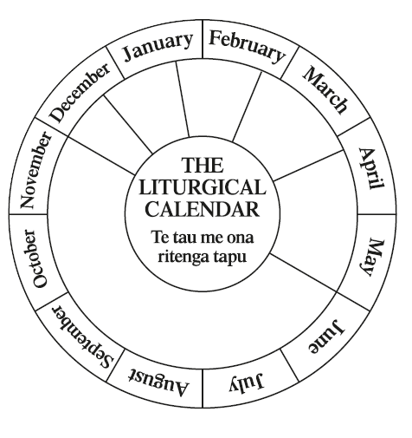  - All Souls Day

