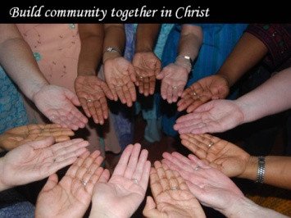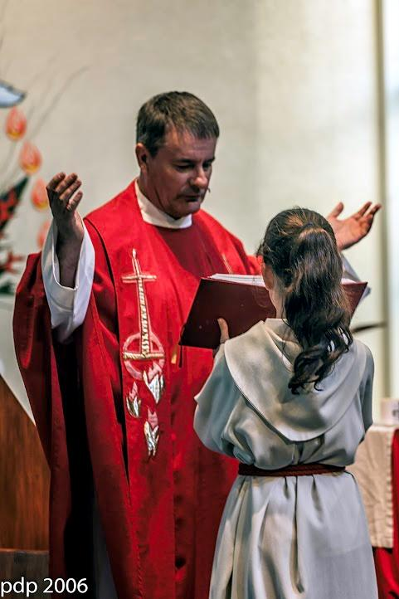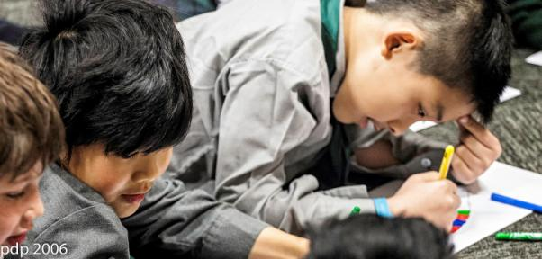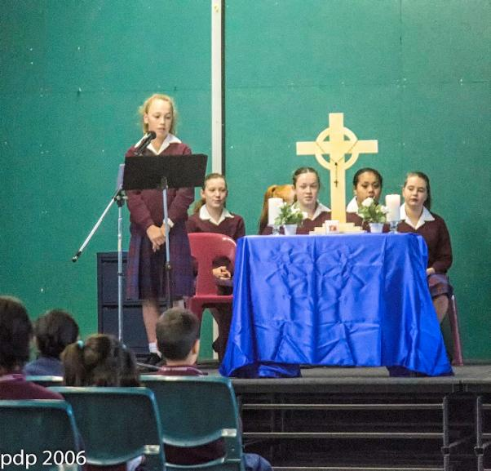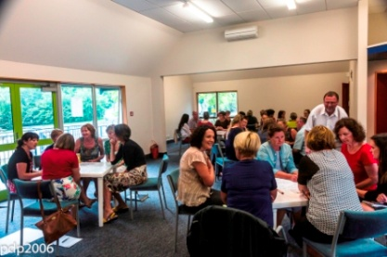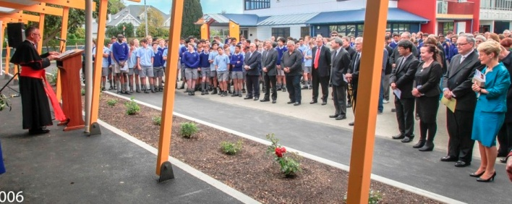

**Catholic Schools**

**Education Services**

**(CSES)**

To provide assistance and support in all aspects of Catholic Education throughout the Archdiocese of Wellington

**CSES Goals**

Goal One:

That our Professional Development meets the needs of our schools.

Goal Two:

To support and implement the priorities of the Archbishop and the NZCBC for schools.

Goal Three:

Grow and develop authentic Catholic leadership at all levels within Catholic Schools.

Goal Four:

Support all Catechetical/ Christian Studies students to become competent & confident in teaching RE and upholding & supporting the Catholic Character.

Goal Five:

That administration of CSES is effective and supports the delivery of quality Catholic education.

Goal Six:

All schools have a clear understanding of the core purpose and function of a Catholic school and of Catholic Character.

CSES Goals

Goal One:

To work with school communities, parishes and faith organizations in the Wellington Archdiocese and New Zealand to promote and support that daily encounter with Christ that is at the heart of Catholic life.

Goal Two:

To work with school and parish communities to grow that leadership in the faith for all so that our schools can be centres which reach out to others with Christ’s message.

Goal Three:

To work with schools to support their vision to become centres of excellence, where each member can express their talents and fulfil their potential.

CSES Goals

Goal One:

To work with school communities, parishes and faith organizations in the Wellington Archdiocese and New Zealand to promote and support that daily encounter with Christ that is at the heart of Catholic life.

Goal Two:

To work with school and parish communities to grow that leadership in the faith for all so that our schools can be centres which reach out to others with Christ’s message.

Goal Three:

To work with schools to support their vision to become centres of excellence, where each member can express their talents and fulfil their potential.

CSES Goals

Goal One:

To work with school communities, parishes and faith organizations in the Wellington Archdiocese and New Zealand to promote and support that daily encounter with Christ that is at the heart of Catholic life.

Goal Two:

To work with school and parish communities to grow that leadership in the faith for all so that our schools can be centres which reach out to others with Christ’s message.

Goal Three:

To work with schools to support their vision to become centres of excellence, where each member can express their talents and fulfil their potential.

CSES Goals

Goal One:

To work with school communities, parishes and faith organizations in the Wellington Archdiocese and New Zealand to promote and support that daily encounter with Christ that is at the heart of Catholic life.

Goal Two:

To work with school and parish communities to grow that leadership in the faith for all so that our schools can be centres which reach out to others with Christ’s message.

Goal Three:

To work with schools to support their vision to become centres of excellence, where each member can express their talents and fulfil their potential.

CSES Goals

Goal One:

To work with school communities, parishes and faith organizations in the Wellington Archdiocese and New Zealand to promote and support that daily encounter with Christ that is at the heart of Catholic life.

Goal Two:

To work with school and parish communities to grow that leadership in the faith for all so that our schools can be centres which reach out to others with Christ’s message.

Goal Three:

To work with schools to support their vision to become centres of excellence, where each member can express their talents and fulfil their potential.

CSES Goals

Goal One:

To work with school communities, parishes and faith organizations in the Wellington Archdiocese and New Zealand to promote and support that daily encounter with Christ that is at the heart of Catholic life.

Goal Two:

To work with school and parish communities to grow that leadership in the faith for all so that our schools can be centres which reach out to others with Christ’s message.

Goal Three:

To work with schools to support their vision to become centres of excellence, where each member can express their talents and fulfil their potential.

CSES Goals

Goal One:

To work with school communities, parishes and faith organizations in the Wellington Archdiocese and New Zealand to promote and support that daily encounter with Christ that is at the heart of Catholic life.

Goal Two:

To work with school and parish communities to grow that leadership in the faith for all so that our schools can be centres which reach out to others with Christ’s message.

Goal Three:

To work with schools to support their vision to become centres of excellence, where each member can express their talents and fulfil their potential.

CSES Goals

Goal One:

To work with school communities, parishes and faith organisations in the Wellington Archdiocese and New Zealand to promote and support that daily encounter with Christ that is at the heart of Catholic life.

Goal Two:

To work with school and parish communities to grow that leadership in the faith for all so that our schools can be centres which reach out to others with Christ’s message.

Goal Three:

To work with schools to support their vision to become centres of excellence, where each member can express their talents and fulfil their potential.

CSES Goals

Goal One:

To work with school communities, parishes and faith organizations in the Wellington Archdiocese and New Zealand to promote and support that daily encounter with Christ that is at the heart of Catholic life.

Goal Two:

To work with school and parish communities to grow that leadership in the faith for all so that our schools can be centres which reach out to others with Christ’s message.

Goal Three:

To work with schools to support their vision to become centres of excellence, where each member can express their talents and fulfil their potential.

CSES Goals

Goal One:

To work with school communities, parishes and faith organizations in the Wellington Archdiocese and New Zealand to promote and support that daily encounter with Christ that is at the heart of Catholic life.

Goal Two:

To work with school and parish communities to grow that leadership in the faith for all so that our schools can be centres which reach out to others with Christ’s message.

Goal Three:

To work with schools to support their vision to become centres of excellence, where each member can express their talents and fulfil their potential.

CSES Goals

Goal One:

To work with school communities, parishes and faith organizations in the Wellington Archdiocese and New Zealand to promote and support that daily encounter with Christ that is at the heart of Catholic life.

Goal Two:

To work with school and parish communities to grow that leadership in the faith for all so that our schools can be centres which reach out to others with Christ’s message.

Goal Three:

To work with schools to support their vision to become centres of excellence, where each member can express their talents and fulfil their potential.

CSES Goals

Goal One:

To work with school communities, parishes and faith organizations in the Wellington Archdiocese and New Zealand to promote and support that daily encounter with Christ that is at the heart of Catholic life.

Goal Two:

To work with school and parish communities to grow that leadership in the faith for all so that our schools can be centres which reach out to others with Christ’s message.

Goal Three:

To work with schools to support their vision to become centres of excellence, where each member can express their talents and fulfil their potential.

CSES Goals

Goal One:

To work with school communities, parishes and faith organizations in the Wellington Archdiocese and New Zealand to promote and support that daily encounter with Christ that is at the heart of Catholic life.

Goal Two:

To work with school and parish communities to grow that leadership in the faith for all so that our schools can be centres which reach out to others with Christ’s message.

Goal Three:

To work with schools to support their vision to become centres of excellence, where each member can express their talents and fulfil their potential.

CSES Goals

Goal One:

To work with school communities, parishes and faith organizations in the Wellington Archdiocese and New Zealand to promote and support that daily encounter with Christ that is at the heart of Catholic life.

Goal Two:

To work with school and parish communities to grow that leadership in the faith for all so that our schools can be centres which reach out to others with Christ’s message.

Goal Three:

To work with schools to support their vision to become centres of excellence, where each member can express their talents and fulfil their potential.

CSES Goals

Goal One:

To work with school communities, parishes and faith organizations in the Wellington Archdiocese and New Zealand to promote and support that daily encounter with Christ that is at the heart of Catholic life.

Goal Two:

To work with school and parish communities to grow that leadership in the faith for all so that our schools can be centres which reach out to others with Christ’s message.

Goal Three:

To work with schools to support their vision to become centres of excellence, where each member can express their talents and fulfil their potential.

CSES Goals

Goal One:

To work with school communities, parishes and faith organisations in the Wellington Archdiocese and New Zealand to promote and support that daily encounter with Christ that is at the heart of Catholic life.

Goal Two:

To work with school and parish communities to grow that leadership in the faith for all so that our schools can be centres which reach out to others with Christ’s message.

Goal Three:

To work with schools to support their vision to become centres of excellence, where each member can express their talents and fulfil their potential.

CSES Goals

Goal One:

To work with school communities, parishes and faith organizations in the Wellington Archdiocese and New Zealand to promote and support that daily encounter with Christ that is at the heart of Catholic life.

Goal Two:

To work with school and parish communities to grow that leadership in the faith for all so that our schools can be centres which reach out to others with Christ’s message.

Goal Three:

To work with schools to support their vision to become centres of excellence, where each member can express their talents and fulfil their potential.

CSES Goals

Goal One:

To work with school communities, parishes and faith organizations in the Wellington Archdiocese and New Zealand to promote and support that daily encounter with Christ that is at the heart of Catholic life.

Goal Two:

To work with school and parish communities to grow that leadership in the faith for all so that our schools can be centres which reach out to others with Christ’s message.

Goal Three:

To work with schools to support their vision to become centres of excellence, where each member can express their talents and fulfil their potential.

CSES Goals

Goal One:

To work with school communities, parishes and faith organizations in the Wellington Archdiocese and New Zealand to promote and support that daily encounter with Christ that is at the heart of Catholic life.

Goal Two:

To work with school and parish communities to grow that leadership in the faith for all so that our schools can be centres which reach out to others with Christ’s message.

Goal Three:

To work with schools to support their vision to become centres of excellence, where each member can express their talents and fulfil their potential.

CSES Goals

Goal One:

To work with school communities, parishes and faith organizations in the Wellington Archdiocese and New Zealand to promote and support that daily encounter with Christ that is at the heart of Catholic life.

Goal Two:

To work with school and parish communities to grow that leadership in the faith for all so that our schools can be centres which reach out to others with Christ’s message.

Goal Three:

To work with schools to support their vision to become centres of excellence, where each member can express their talents and fulfil their potential.

CSES Goals

Goal One:

To work with school communities, parishes and faith organizations in the Wellington Archdiocese and New Zealand to promote and support that daily encounter with Christ that is at the heart of Catholic life.

Goal Two:

To work with school and parish communities to grow that leadership in the faith for all so that our schools can be centres which reach out to others with Christ’s message.

Goal Three:

To work with schools to support their vision to become centres of excellence, where each member can express their talents and fulfil their potential.

CSES Goals

Goal One:

To work with school communities, parishes and faith organizations in the Wellington Archdiocese and New Zealand to promote and support that daily encounter with Christ that is at the heart of Catholic life.

Goal Two:

To work with school and parish communities to grow that leadership in the faith for all so that our schools can be centres which reach out to others with Christ’s message.

Goal Three:

To work with schools to support their vision to become centres of excellence, where each member can express their talents and fulfil their potential.

CSES Goals

Goal One:

To work with school communities, parishes and faith organizations in the Wellington Archdiocese and New Zealand to promote and support that daily encounter with Christ that is at the heart of Catholic life.

Goal Two:

To work with school and parish communities to grow that leadership in the faith for all so that our schools can be centres which reach out to others with Christ’s message.

Goal Three:

To work with schools to support their vision to become centres of excellence, where each member can express their talents and fulfil their potential.

CSES Goals

Goal One:

To work with school communities, parishes and faith organisations in the Wellington Archdiocese and New Zealand to promote and support that daily encounter with Christ that is at the heart of Catholic life.

Goal Two:

To work with school and parish communities to grow that leadership in the faith for all so that our schools can be centres which reach out to others with Christ’s message.

Goal Three:

To work with schools to support their vision to become centres of excellence, where each member can express their talents and fulfil their potential.

CSES Goals

Goal One:

To work with school communities, parishes and faith organizations in the Wellington Archdiocese and New Zealand to promote and support that daily encounter with Christ that is at the heart of Catholic life.

Goal Two:

To work with school and parish communities to grow that leadership in the faith for all so that our schools can be centres which reach out to others with Christ’s message.

Goal Three:

To work with schools to support their vision to become centres of excellence, where each member can express their talents and fulfil their potential.

CSES Goals

Goal One:

To work with school communities, parishes and faith organizations in the Wellington Archdiocese and New Zealand to promote and support that daily encounter with Christ that is at the heart of Catholic life.

Goal Two:

To work with school and parish communities to grow that leadership in the faith for all so that our schools can be centres which reach out to others with Christ’s message.

Goal Three:

To work with schools to support their vision to become centres of excellence, where each member can express their talents and fulfil their potential.

CSES Goals

Goal One:

To work with school communities, parishes and faith organizations in the Wellington Archdiocese and New Zealand to promote and support that daily encounter with Christ that is at the heart of Catholic life.

Goal Two:

To work with school and parish communities to grow that leadership in the faith for all so that our schools can be centres which reach out to others with Christ’s message.

Goal Three:

To work with schools to support their vision to become centres of excellence, where each member can express their talents and fulfil their potential.

CSES Goals

Goal One:

To work with school communities, parishes and faith organizations in the Wellington Archdiocese and New Zealand to promote and support that daily encounter with Christ that is at the heart of Catholic life.

Goal Two:

To work with school and parish communities to grow that leadership in the faith for all so that our schools can be centres which reach out to others with Christ’s message.

Goal Three:

To work with schools to support their vision to become centres of excellence, where each member can express their talents and fulfil their potential.

CSES Goals

Goal One:

To work with school communities, parishes and faith organizations in the Wellington Archdiocese and New Zealand to promote and support that daily encounter with Christ that is at the heart of Catholic life.

Goal Two:

To work with school and parish communities to grow that leadership in the faith for all so that our schools can be centres which reach out to others with Christ’s message.

Goal Three:

To work with schools to support their vision to become centres of excellence, where each member can express their talents and fulfil their potential.

CSES Goals

Goal One:

To work with school communities, parishes and faith organizations in the Wellington Archdiocese and New Zealand to promote and support that daily encounter with Christ that is at the heart of Catholic life.

Goal Two:

To work with school and parish communities to grow that leadership in the faith for all so that our schools can be centres which reach out to others with Christ’s message.

Goal Three:

To work with schools to support their vision to become centres of excellence, where each member can express their talents and fulfil their potential.

CSES Goals

Goal One:

To work with school communities, parishes and faith organizations in the Wellington Archdiocese and New Zealand to promote and support that daily encounter with Christ that is at the heart of Catholic life.

Goal Two:

To work with school and parish communities to grow that leadership in the faith for all so that our schools can be centres which reach out to others with Christ’s message.

Goal Three:

To work with schools to support their vision to become centres of excellence, where each member can express their talents and fulfil their potential.

Goal One:

That our Professional Development meets the needs of our schools.

Goal Two:

To support and implement the priorities of the Archbishop and the NZCBC for schools.

Goal Three:

Grow and develop authentic Catholic leadership at all levels within Catholic Schools.

Goal Four:

Support all Catechetical/ Christian Studies students to become competent & confident in teaching RE and upholding & supporting the Catholic Character.

Goal Five:

That administration of CSES is effective and supports the delivery of quality Catholic education.

Goal Six:

All schools have a clear understanding of the core purpose and function of a Catholic school and of Catholic Character.

CSES Goals

Goal One:

To work with school communities, parishes and faith organizations in the Wellington Archdiocese and New Zealand to promote and support that daily encounter with Christ that is at the heart of Catholic life.

Goal Two:

To work with school and parish communities to grow that leadership in the faith for all so that our schools can be centres which reach out to others with Christ’s message.

Goal Three:

To work with schools to support their vision to become centres of excellence, where each member can express their talents and fulfil their potential.

CSES Goals

Goal One:

To work with school communities, parishes and faith organizations in the Wellington Archdiocese and New Zealand to promote and support that daily encounter with Christ that is at the heart of Catholic life.

Goal Two:

To work with school and parish communities to grow that leadership in the faith for all so that our schools can be centres which reach out to others with Christ’s message.

Goal Three:

To work with schools to support their vision to become centres of excellence, where each member can express their talents and fulfil their potential.

CSES Goals

Goal One:

To work with school communities, parishes and faith organizations in the Wellington Archdiocese and New Zealand to promote and support that daily encounter with Christ that is at the heart of Catholic life.

Goal Two:

To work with school and parish communities to grow that leadership in the faith for all so that our schools can be centres which reach out to others with Christ’s message.

Goal Three:

To work with schools to support their vision to become centres of excellence, where each member can express their talents and fulfil their potential.

CSES Goals

Goal One:

To work with school communities, parishes and faith organizations in the Wellington Archdiocese and New Zealand to promote and support that daily encounter with Christ that is at the heart of Catholic life.

Goal Two:

To work with school and parish communities to grow that leadership in the faith for all so that our schools can be centres which reach out to others with Christ’s message.

Goal Three:

To work with schools to support their vision to become centres of excellence, where each member can express their talents and fulfil their potential.

CSES Goals

Goal One:

To work with school communities, parishes and faith organizations in the Wellington Archdiocese and New Zealand to promote and support that daily encounter with Christ that is at the heart of Catholic life.

Goal Two:

To work with school and parish communities to grow that leadership in the faith for all so that our schools can be centres which reach out to others with Christ’s message.

Goal Three:

To work with schools to support their vision to become centres of excellence, where each member can express their talents and fulfil their potential.

CSES Goals

Goal One:

To work with school communities, parishes and faith organizations in the Wellington Archdiocese and New Zealand to promote and support that daily encounter with Christ that is at the heart of Catholic life.

Goal Two:

To work with school and parish communities to grow that leadership in the faith for all so that our schools can be centres which reach out to others with Christ’s message.

Goal Three:

To work with schools to support their vision to become centres of excellence, where each member can express their talents and fulfil their potential.

CSES Goals

Goal One:

To work with school communities, parishes and faith organizations in the Wellington Archdiocese and New Zealand to promote and support that daily encounter with Christ that is at the heart of Catholic life.

Goal Two:

To work with school and parish communities to grow that leadership in the faith for all so that our schools can be centres which reach out to others with Christ’s message.

Goal Three:

To work with schools to support their vision to become centres of excellence, where each member can express their talents and fulfil their potential.

CSES Goals

Goal One:

To work with school communities, parishes and faith organisations in the Wellington Archdiocese and New Zealand to promote and support that daily encounter with Christ that is at the heart of Catholic life.

Goal Two:

To work with school and parish communities to grow that leadership in the faith for all so that our schools can be centres which reach out to others with Christ’s message.

Goal Three:

To work with schools to support their vision to become centres of excellence, where each member can express their talents and fulfil their potential.

CSES Goals

Goal One:

To work with school communities, parishes and faith organizations in the Wellington Archdiocese and New Zealand to promote and support that daily encounter with Christ that is at the heart of Catholic life.

Goal Two:

To work with school and parish communities to grow that leadership in the faith for all so that our schools can be centres which reach out to others with Christ’s message.

Goal Three:

To work with schools to support their vision to become centres of excellence, where each member can express their talents and fulfil their potential.

CSES Goals

Goal One:

To work with school communities, parishes and faith organizations in the Wellington Archdiocese and New Zealand to promote and support that daily encounter with Christ that is at the heart of Catholic life.

Goal Two:

To work with school and parish communities to grow that leadership in the faith for all so that our schools can be centres which reach out to others with Christ’s message.

Goal Three:

To work with schools to support their vision to become centres of excellence, where each member can express their talents and fulfil their potential.

CSES Goals

Goal One:

To work with school communities, parishes and faith organizations in the Wellington Archdiocese and New Zealand to promote and support that daily encounter with Christ that is at the heart of Catholic life.

Goal Two:

To work with school and parish communities to grow that leadership in the faith for all so that our schools can be centres which reach out to others with Christ’s message.

Goal Three:

To work with schools to support their vision to become centres of excellence, where each member can express their talents and fulfil their potential.

CSES Goals

Goal One:

To work with school communities, parishes and faith organizations in the Wellington Archdiocese and New Zealand to promote and support that daily encounter with Christ that is at the heart of Catholic life.

Goal Two:

To work with school and parish communities to grow that leadership in the faith for all so that our schools can be centres which reach out to others with Christ’s message.

Goal Three:

To work with schools to support their vision to become centres of excellence, where each member can express their talents and fulfil their potential.

CSES Goals

Goal One:

To work with school communities, parishes and faith organizations in the Wellington Archdiocese and New Zealand to promote and support that daily encounter with Christ that is at the heart of Catholic life.

Goal Two:

To work with school and parish communities to grow that leadership in the faith for all so that our schools can be centres which reach out to others with Christ’s message.

Goal Three:

To work with schools to support their vision to become centres of excellence, where each member can express their talents and fulfil their potential.

CSES Goals

Goal One:

To work with school communities, parishes and faith organizations in the Wellington Archdiocese and New Zealand to promote and support that daily encounter with Christ that is at the heart of Catholic life.

Goal Two:

To work with school and parish communities to grow that leadership in the faith for all so that our schools can be centres which reach out to others with Christ’s message.

Goal Three:

To work with schools to support their vision to become centres of excellence, where each member can express their talents and fulfil their potential.

CSES Goals

Goal One:

To work with school communities, parishes and faith organizations in the Wellington Archdiocese and New Zealand to promote and support that daily encounter with Christ that is at the heart of Catholic life.

Goal Two:

To work with school and parish communities to grow that leadership in the faith for all so that our schools can be centres which reach out to others with Christ’s message.

Goal Three:

To work with schools to support their vision to become centres of excellence, where each member can express their talents and fulfil their potential.

CSES Goals

Goal One:

To work with school communities, parishes and faith organisations in the Wellington Archdiocese and New Zealand to promote and support that daily encounter with Christ that is at the heart of Catholic life.

Goal Two:

To work with school and parish communities to grow that leadership in the faith for all so that our schools can be centres which reach out to others with Christ’s message.

Goal Three:

To work with schools to support their vision to become centres of excellence, where each member can express their talents and fulfil their potential.

CSES Goals

Goal One:

To work with school communities, parishes and faith organizations in the Wellington Archdiocese and New Zealand to promote and support that daily encounter with Christ that is at the heart of Catholic life.

Goal Two:

To work with school and parish communities to grow that leadership in the faith for all so that our schools can be centres which reach out to others with Christ’s message.

Goal Three:

To work with schools to support their vision to become centres of excellence, where each member can express their talents and fulfil their potential.

CSES Goals

Goal One:

To work with school communities, parishes and faith organizations in the Wellington Archdiocese and New Zealand to promote and support that daily encounter with Christ that is at the heart of Catholic life.

Goal Two:

To work with school and parish communities to grow that leadership in the faith for all so that our schools can be centres which reach out to others with Christ’s message.

Goal Three:

To work with schools to support their vision to become centres of excellence, where each member can express their talents and fulfil their potential.

CSES Goals

Goal One:

To work with school communities, parishes and faith organizations in the Wellington Archdiocese and New Zealand to promote and support that daily encounter with Christ that is at the heart of Catholic life.

Goal Two:

To work with school and parish communities to grow that leadership in the faith for all so that our schools can be centres which reach out to others with Christ’s message.

Goal Three:

To work with schools to support their vision to become centres of excellence, where each member can express their talents and fulfil their potential.

CSES Goals

Goal One:

To work with school communities, parishes and faith organizations in the Wellington Archdiocese and New Zealand to promote and support that daily encounter with Christ that is at the heart of Catholic life.

Goal Two:

To work with school and parish communities to grow that leadership in the faith for all so that our schools can be centres which reach out to others with Christ’s message.

Goal Three:

To work with schools to support their vision to become centres of excellence, where each member can express their talents and fulfil their potential.

CSES Goals

Goal One:

To work with school communities, parishes and faith organizations in the Wellington Archdiocese and New Zealand to promote and support that daily encounter with Christ that is at the heart of Catholic life.

Goal Two:

To work with school and parish communities to grow that leadership in the faith for all so that our schools can be centres which reach out to others with Christ’s message.

Goal Three:

To work with schools to support their vision to become centres of excellence, where each member can express their talents and fulfil their potential.

CSES Goals

Goal One:

To work with school communities, parishes and faith organizations in the Wellington Archdiocese and New Zealand to promote and support that daily encounter with Christ that is at the heart of Catholic life.

Goal Two:

To work with school and parish communities to grow that leadership in the faith for all so that our schools can be centres which reach out to others with Christ’s message.

Goal Three:

To work with schools to support their vision to become centres of excellence, where each member can express their talents and fulfil their potential.

CSES Goals

Goal One:

To work with school communities, parishes and faith organizations in the Wellington Archdiocese and New Zealand to promote and support that daily encounter with Christ that is at the heart of Catholic life.

Goal Two:

To work with school and parish communities to grow that leadership in the faith for all so that our schools can be centres which reach out to others with Christ’s message.

Goal Three:

To work with schools to support their vision to become centres of excellence, where each member can express their talents and fulfil their potential.

CSES Goals

Goal One:

To work with school communities, parishes and faith organisations in the Wellington Archdiocese and New Zealand to promote and support that daily encounter with Christ that is at the heart of Catholic life.

Goal Two:

To work with school and parish communities to grow that leadership in the faith for all so that our schools can be centres which reach out to others with Christ’s message.

Goal Three:

To work with schools to support their vision to become centres of excellence, where each member can express their talents and fulfil their potential.

CSES Goals

Goal One:

To work with school communities, parishes and faith organizations in the Wellington Archdiocese and New Zealand to promote and support that daily encounter with Christ that is at the heart of Catholic life.

Goal Two:

To work with school and parish communities to grow that leadership in the faith for all so that our schools can be centres which reach out to others with Christ’s message.

Goal Three:

To work with schools to support their vision to become centres of excellence, where each member can express their talents and fulfil their potential.

CSES Goals

Goal One:

To work with school communities, parishes and faith organizations in the Wellington Archdiocese and New Zealand to promote and support that daily encounter with Christ that is at the heart of Catholic life.

Goal Two:

To work with school and parish communities to grow that leadership in the faith for all so that our schools can be centres which reach out to others with Christ’s message.

Goal Three:

To work with schools to support their vision to become centres of excellence, where each member can express their talents and fulfil their potential.

CSES Goals

Goal One:

To work with school communities, parishes and faith organizations in the Wellington Archdiocese and New Zealand to promote and support that daily encounter with Christ that is at the heart of Catholic life.

Goal Two:

To work with school and parish communities to grow that leadership in the faith for all so that our schools can be centres which reach out to others with Christ’s message.

Goal Three:

To work with schools to support their vision to become centres of excellence, where each member can express their talents and fulfil their potential.

CSES Goals

Goal One:

To work with school communities, parishes and faith organizations in the Wellington Archdiocese and New Zealand to promote and support that daily encounter with Christ that is at the heart of Catholic life.

Goal Two:

To work with school and parish communities to grow that leadership in the faith for all so that our schools can be centres which reach out to others with Christ’s message.

Goal Three:

To work with schools to support their vision to become centres of excellence, where each member can express their talents and fulfil their potential.

CSES Goals

Goal One:

To work with school communities, parishes and faith organizations in the Wellington Archdiocese and New Zealand to promote and support that daily encounter with Christ that is at the heart of Catholic life.

Goal Two:

To work with school and parish communities to grow that leadership in the faith for all so that our schools can be centres which reach out to others with Christ’s message.

Goal Three:

To work with schools to support their vision to become centres of excellence, where each member can express their talents and fulfil their potential.

CSES Goals

Goal One:

To work with school communities, parishes and faith organizations in the Wellington Archdiocese and New Zealand to promote and support that daily encounter with Christ that is at the heart of Catholic life.

Goal Two:

To work with school and parish communities to grow that leadership in the faith for all so that our schools can be centres which reach out to others with Christ’s message.

Goal Three:

To work with schools to support their vision to become centres of excellence, where each member can express their talents and fulfil their potential.

CSES Goals

Goal One:

To work with school communities, parishes and faith organizations in the Wellington Archdiocese and New Zealand to promote and support that daily encounter with Christ that is at the heart of Catholic life.

Goal Two:

To work with school and parish communities to grow that leadership in the faith for all so that our schools can be centres which reach out to others with Christ’s message.

Goal Three:

To work with schools to support their vision to become centres of excellence, where each member can express their talents and fulfil their potential.

**Catholic Centre, 22-30 Hill Street**

**PO Box 1937 Wellington 6140**

**Phone: (04) 496 1710**

**Email : cses@wn.catholic.org.nz**

*“Act justly, love tenderly and walk*

*humbly with your God”*

Micah 6:8

PERSONNEL PROFILES

**OFFICE FOR THE VICAR FOR EDUCATION**

**Jenny Gordon - Vicar for Education**

Archbishop’s representative appointed to exercise local jurisdiction on “all things” pertaining to Catholic Education, particularly his responsibilities as Proprietor now pursuant to Pt 33 of the Education Act 1989 (previously the Private Schools Conditional Integration Act).

Point of contact for any area of statutory requirements and/or formal consultation on:

* S464 positions
* Maximum rolls, allocation for increase
* Non-preference rolls
* Preference Certificates - advice, issues and appeals
* Appointments - process and legalities
* Annual Attestation of Compliance
* Proprietor’s appointees - appointments, registrations and reports

Proprietor Consultation

* Charter and Health Syllabus - Bi-annual
* Enrolment Policy

**Phone (04) 496 1735**

**Email:** [**j.gordon@wn.catholic.org.nz**](mailto:j.gordon@wn.catholic.org.nz)

sharing our faith,

celebrating God in our lives,

building community

for participation in a changing world;

creating effective learning environments and providing support for their growth

sharing our faith,

celebrating God in our lives,

building community

for participation in a changing world;

creating effective learning environments and providing support for their growth

sharing our faith,

celebrating God in our lives,

building community

for participation in a changing world;

creating effective learning environments and providing support for their growth

sharing our faith,

celebrating God in our lives,

building community

for participation in a changing world;

creating effective learning environments and providing support for their growth

sharing our faith,

celebrating God in our lives,

building community

for participation in a changing world;

creating effective learning environments and providing support for their growth

sharing our faith,

celebrating God in our lives,

building community

for participation in a changing world;

creating effective learning environments and providing support for their growth

sharing our faith,

celebrating God in our lives,

building community

for participation in a changing world;

creating effective learning environments and providing support for their growth

sharing our faith,

celebrating God in our lives,

building community

for participation in a changing world;

creating effective learning environments and providing support for their growth

**ADMINISTRATOR**

**Ginny McCarty**

Co-ordination of services and point of contact for:

* Professional Development Records and processing Certification
* Special Character and Development Reviews
* S Forms
* Support of CSES Team
* Course registration.

**Phone (04) 496 1710**

**Email: cses@wn.catholic.org.nz**

**LEADERSHIP CONSULTANT**

**Frank Wafer**

* Understanding Catholic Character at all levels
* Leadership issues and development
* Relationships at all levels
* Board of Trustees
* Other issues affecting the wellbeing of Principals and Staff

**Phone (04) 496 1738**

**Email:** [**f.wafer@wn.catholic.org.nz**](mailto:f.wafer@wn.catholic.org.nz)

**CONSULTANT TO PRIMARY SCHOOLS**

**Alan Grant**

* Professional Development courses for teachers
* Support programme for teachers new to Catholic Education and beginning teachers
* Assistance with whole school and classroom Religious Education (RE) planning and delivery
* Guidance, planning and lesson appraisal toward Certification
* Support and planning for school liturgy
* Course Delivery - Having Life to the Full (Jn10:10- was Understanding Sexuality)

**Phone: (04) 496 1335**

**Email:** [**a.grant@wn.catholic.org.nz**](mailto:a.grant@wn.catholic.org.nz)

**CONSULTANT TO SECONDARY SCHOOLS**

**David Sullivan**

* Induction Courses for teachers new to Catholic Schools and for those new to teaching Religious Education (R.E.)
* Cluster meetings for DRS’s to enable them to support one another and share strategies
* Promote Diploma Courses
* Counsellors’ meetings to enable them to maintain and develop Catholic Character
* Workshops for RE teachers for collaborative sharing and development of skills and ideas
* Help with resources
* Lesson appraisals for Certification when requested
* Assist provisionally registered teachers

**Phone (04) 496 1708**

**Email:** [**d.sullivan@wn.catholic.org.nz**](mailto:d.sullivan@wn.catholic.org.nz)