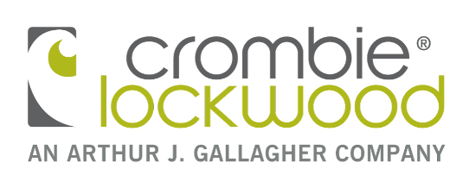
Property Claim Form
gek-tuor.kuoch@crombielockwood.co.nz

This form collects personal information about you so we can consider your claim and update your insurances. It will be held by Crombie Lockwood (NZ) Limited and the underwriter who handles your claim. You may request access to, and correction of, this information subject to the provisions of the Privacy Act 1993. The collection of this information by Crombie Lockwood (NZ) Limited is required under the terms of your insurance policy. Failure to provide this information may result in your claim being declined.
PERSONAL DETAILS
Insured Name: |  |  |  |  |  |  |  |  |  |  |  | Policy reference / Client number or Claim number
Contact Person: |  |  |  |  |  |  |  |  |  |  |  | Contact Phone no’s:
Email: |  |  |  |  |  |  |  |  |  |  |  | Fax:
Address:
Preferred method of contact?
Crombie Lockwood Branch you are insured through:
LOSS DETAILS
1. When did the loss occur? |  |  | Time: |  |  |  |  |  |  |  | Date:
2. Where did the loss occur? |  |  | Street: |  |  |  |  |  |  |  | Town:
3. What happened and how did it occur?
If the answer is "Yes" for questions 4 to 8 inclusive please supply full details.
4. Does someone other than you own any of the damaged property/assets? |  |  |  |  | Yes No If Yes - details:
5. Do you know who was responsible for the loss? |  |  |  |  | Yes No If Yes - details:
6. Is there finance on any of the property claimed for? |  |  |  |  | Yes No If Yes - details:
7. Were the police notified?  (if “Yes” please provide police file number). |  |  |  |  | Yes No If Yes - details:
8. Is there other insurance on this property? |  |  |  |  | Yes No If Yes - details:
9. LOSS SCHEDULE
Your Insurer will require proof of ownership e.g photos, receipts, manuals etc.
If the item is damaged they will require a damage report confirming if it is repairable and the cause of the damage.
Please also include a replacement quote to repair/replace.
Description, include make and model |  |  |  | Purchased New  Yes No |  |  |  | Present Purchase Price |  | Age of Item |  |  | Where purchased? |  |  | Repairable?  Yes No

Further Information or Comments:
10. DECLARATION
I declare that to the best of my knowledge the details given in this claim form are true.
I undertake to render all possible assistance in connection with this claim.
I agree that Crombie Lockwood (NZ) Limited and the insurance company (and/or their agent) with whom I am insured
may give to or obtain from appropriate individuals or organisations information relevant to this claim.
I agree that the insurance company with whom I am insured may give to or obtain from ICR details of information
relevant to this claim. (The Insurance Claims Register Ltd (ICR) holds details of claims under policies issued by
participating insurers. Participating insurers can check details of your claims history on the ICR.)
Note: Failure to provide correct and complete information could result on your claim not being accepted by the insurance company.
I have read and I understand the above Declaration
Name of Insured
(person completing this form):
Date:

DIRECT CREDIT DETAILS

Bank Branch Number Account Number Suffix

Account Name:

