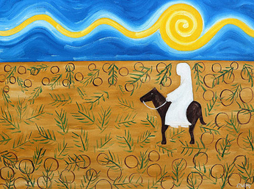

Passion Sunday 5 April 2020

Gospel for Procession of Palms: Matthew 21:1-11

Liturgy of the Word
Isaiah 50:4-7
Philippians 2:6-11
Matthew 26: 14-27, 66 (The Passion of Jesus Christ) -Patrick J Murphy
Jesus comes into your city or town at this time of COVID 19.
He enters into a place of desertion and isolation.
He sees people shut in behind their windows.
He hears silence, not adulation.
He meets no children excitedly waving branches.
It is like street theatre with no body watching.

“Who is this?” some people ask.
Others call out “This is the Prophet Jesus from Nazareth in Galilee.” Matthew 21:10-11

Imagine Jesus coming into your street… your home… into a place of essential workers…
What do you notice about Jesus?
Become aware of how you feel on seeing him.

What might Jesus mean by this solitary action… coming unprotected into your deserted town?
Does he see the street signs? Walk solo. Keep two metres apart. Stay at home especially if you’re over 70 or have compromised health. Don’t mix with others outside your bubble….

“Hosanna to the One who comes in the name of the Lord… Hosanna to the king! Matthew 21:9

So what kind of a “king” is he?
This is vulnerable Jesus whose heart is breaking.
This is Jesus who craves human touch and comfort at this time on the edge of his passion and death.
This is Jesus who wept at the death of his friend, Lazarus.
This is Jesus who talked about seeds, bread, fish, vines, children and being just, forgiving and loving to one another. This is Jesus who shared food.
This is Jesus who slept on that cushion in the boat during a storm while the disciples grew panicked and fearful.

Invite Jesus into your home today, or wherever you are. Invite him into your centre.
Think of how he understands what you are going through at this time of COVID 19.
Ask him for what you or our world needs today as we enter into a different kind of Holy Week- one of isolation, fear and more aloneness than we’d ever anticipated… but a Holy Week journey in which we believe there are the seeds of hope and justice, kindness and love. Seeds that can transform the world.

--Anne Powell, Cenacle Sisters

