2 April 2020
7 more poems in the time of Corona Virus Lockdown
- Anne Powell

Blue

the blues are small
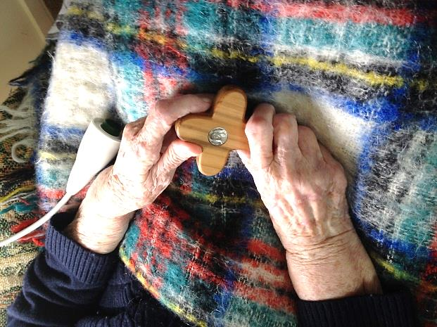
songs for big sorrows
potato crop blight
meatworks close
purse empties
candle ends

lessening of love
petals on table
loss of job
falling of tears
the blues are small
songs for big sorrows.

Horizons

Morning star
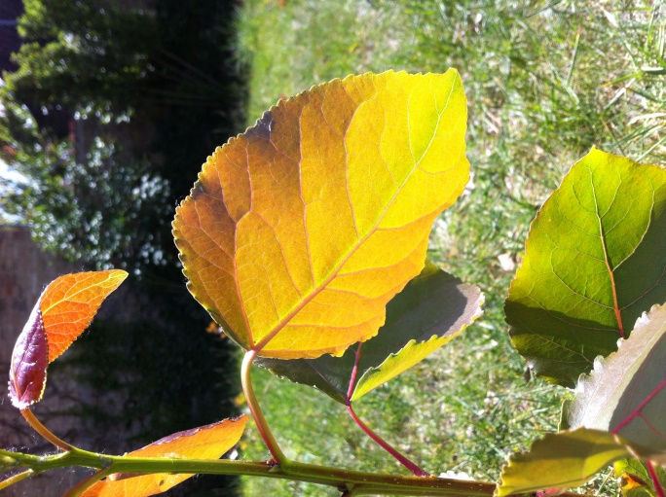
let there be light.

Between the leaves
let there be light.

Children’s faces
let there be light.

On the horizon
let there be light.

Arc of rainbow
let there be light.

Candle at window
let there be light.

Moments
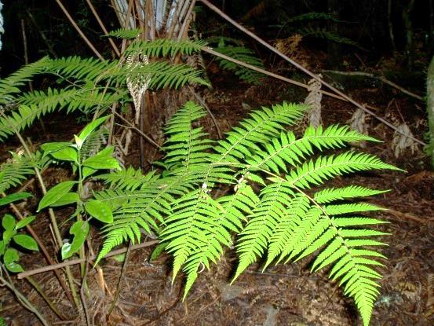
In moments of loss and pain
sit quietly among green of fern
and remember
all is cyclical.

Time for a change

We are targets of time
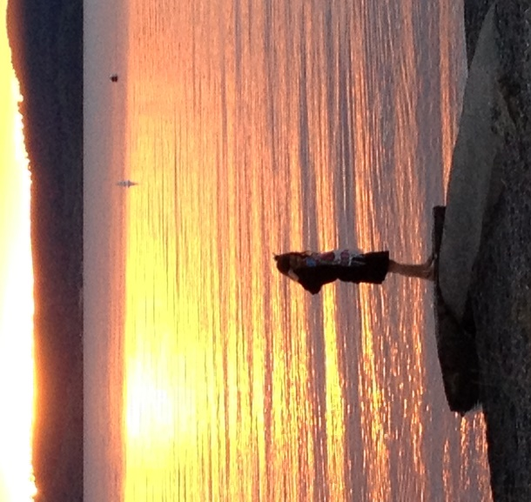
racing through supermarkets
captured by meals-in-a- moment.

We are targets of time
hurrying on highways
arriving dead on time.

We are targets of time
possessed of longing for solitude
yearning for stillness of air.

Land pictures

The land is power
pulling our souls
in under hills
deep into caves of no light
and glimmers of light like glow-worms.
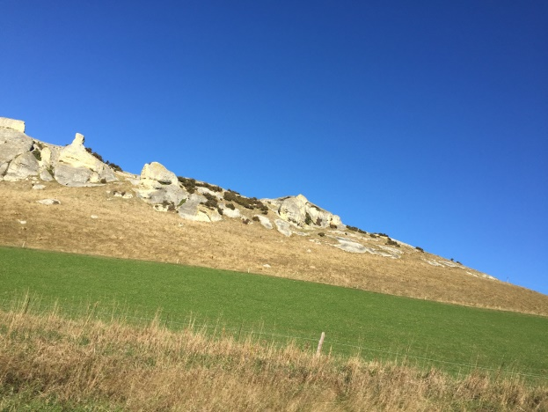
The land is mother
holding our grief
in tears of rivers
and our cries
in open arms of bays.

The land is grandparent
rocking our childhood
in hollows of hiding
and hillsides for sliding
and plains as open as pikelets.

To hear trees speak

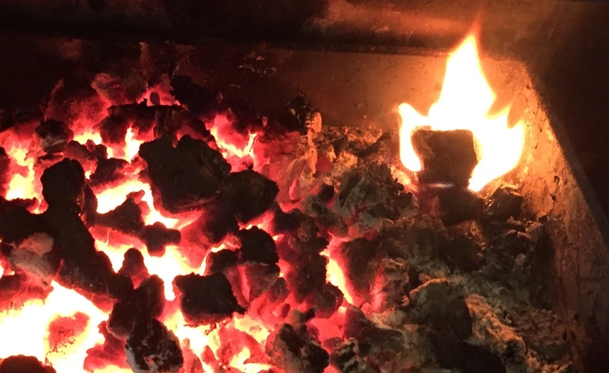
Water
earth
air
fire birthing God.

Dark
moon
sun
light birthing God.

Stars
woman
man
humans being bare enough to hear trees speak.

Now our love of owning
and of burning trees deafens us
to all but our own voice.

Litany

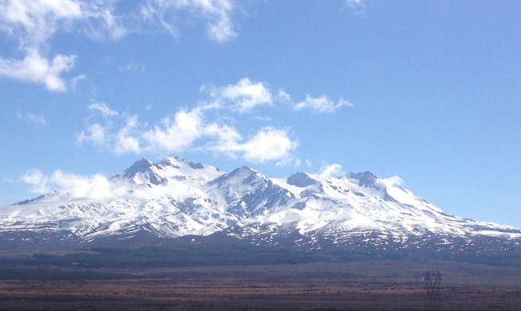
Solemnity of mountain strengthen us
Crescent of moon shield us.
Wand of star guide us.
Fall of leaf teach us.
Circle of love companion us.
Horizon of hope console us.

26 March 2020

Prayer for Life During COVID-19 Lockdown
Written by Mary Jackson Kay, Cenacle Sister for use by anyone

Welcome to this time of prayer, reflection and sharing as we begin Level 4 Lockdown to combat COVID-19.

As we come to terms with physical distancing may it lead us to deeper intimacy and great unity in our hearts and in the entire world.

In John’s Gospel 15:4 Jesus has reassuring words while we have to stay at home for the greater good:
“Live in me. Make your home in me just as I do in you.”
I’ll lead us now in a time of prayer individually and then a time of sharing together.

As we begin I invite each of us to take a deep breath, relax and share your name and an image or colour to describe how you are feeling right now….

- The very phrase lock-down can conjure up terrible images….Turn it around…
- What is it you need to lock down, lock out…both personally and in our local and global communities?
- Place it somewhere locked away for this time…

Take a moment to arrive in your body, your mind and your heart. Listen to your breathing….tense your shoulders into a shrug breathing in, hold it a moment, then relax breathing out; shrug again breathing in, hold it and then relax as you breathe out.

- As you settle imagine you are in a safe place that you love, it may be outdoors or inside, on your own or with others.
What does this place look like- notice the colours, the sounds and atmosphere.

- Become aware and welcome the presence of God.

- Share with God how you are feeling and how COVID-19 is impacting your life….especially being asked to distance ourselves physically distance from one another.
- Ask God how you can stay connected with people?

- Ask God for the grace and wisdom you need right now...

- Open your hands in your lap and imagine Jesus is placing a gift in your hands to help you feel that gift, it may be a symbol, a few words, a colour, a song.

- End by give thanks for the gift of this time of prayer.
Noticing your breathing, become aware of where you are and greeting each other with a smile.

- And let us take some time to share with each other now something from your prayer….

End with a blessing of one another……it seems we breath in the dreaded Corona Virus so now let’s safely share our breathe with one another as a blessing….cup your hands and blow health and peace to one another.

Amen

7 Poems for praying in time of
Corona Virus Lockdown
By Anne Powell
Going deeper
Go down
down
down
to the place in you
where fire and silence dwell ~
the place of power.

Go down
down
down
to that pool in you
of weedless water ~
the place of knowing.

Go down
down
down
the moss bright path
to your Grandmother’s house ~
the place of song.

Go down
down
down
to the last strawberry ~
freshness of God.

Visit us

Visit us
in breath of wind
in endurance of cliffs
in glow of kowhai
in silence of stars
in solitude of moon
in eyes of the poor
in embrace of a mother
in pleasure of friends
in faith that does justice.

Hints for middle years

You want to get
to where you’re going
even if you don’t have a map

or a torch
or a long piece of rope
for emergencies
let alone a Band-aid.

The thing is to do the journey.

Enjoy wherever you pass
be it city
or shoreline
or paddock
or people.

And tune your breathing
to the rhythm of soul.

The learning tree

I draw on strength from rising moon
I draw on strength from Mary’s womb.

I draw on strength from tumbling wave.
I draw on strength from One who saves.

I draw on strength from kauri tree.
I draw on strength and learn to be.

Letting go

When it comes to prayer
trying hard is not the answer
Think more of flying
a kite to freedom
on a clear day
or bathing beneath a waterfall
each sense awake
or letting the heart-gaze rest
on beauty.

Beauty opens to presence.
Hafiz would shout
“enjoy the love-ride, my friend."

Like a koru

I am a listener
hearing
the split of silence
at Huka Falls.

I am a singer
making
music on the wind
in the tussocks.

I am a woman
awaiting
the rise of yeast
and the sound of bread growing.

I am a traveller
opening
like a koru
my ear.

Aotearoa Litany

Green of fern refresh us
Feathers of kereru warm us
Rocks of Moeraki encircle us
Waters of Taupo bathe us
Dive of gannet focus us
Arc of rainbow protect us
Stars of Southern Cross guide us

