Suggestions for Prayer at Home over Holy Week
Fr Patrick Bridgman, Liturgy Adviser Archdiocese of Wellington
In these days as we approach Holy Week, we are like our ancestors not having the full rituals of the Church available. How we remember the Most Holy of Weeks will be by our own choice personally or as a family; yet we know that we are in communion with the faith community of our parish and the local Church; our diocese, and the Church world-wide.
The following are simple suggestions for Palm Sunday, and the Triduum; Holy Thursday, Good Friday, and Easter Sunday. These moments of prayer are sourced in the Missal from which we pray when we are together, and so the words and symbols are familiar to us. They are already part of our prayer life. You may like to pray at the times you would normally gather with your faith community in the parish so to emphasis the reality of our communion with each other.

Palm Sunday
Each year we gather to commemorate the Lord’s Entrance into Jerusalem. For our prayer today we could go into our gardens and cut a small branch in readiness for the blessing.
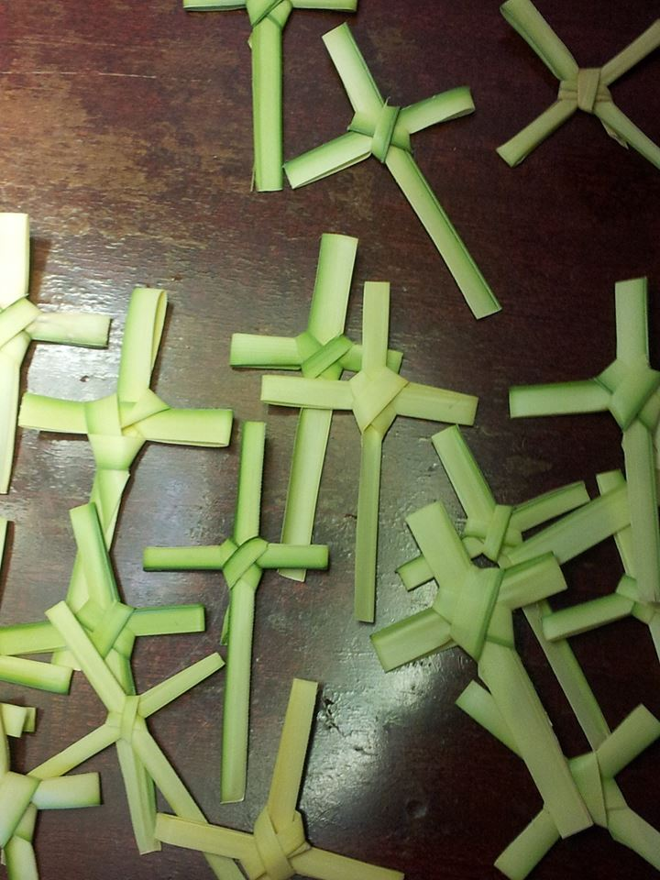
If children are present in the house, they may enjoy this task. If the weather is fine you could gather outside with the branches and pray with the words of the Church. In prayer someone could speak aloud how we have been preparing our hearts during Lent by penance and charitable works, and that now we announce with the whole Church the beginning of the celebration of the Lord’s Paschal Mystery, that is to say, of his Passion and Resurrection.
With branches held high we could pray with these words or similar:
Almighty ever-living God,
make holy these branches with your blessing,
that we who follow Christ the King with joy,
may reach the heavenly Jerusalem through him.
who lives and reigns for ever and ever. Amen

Following the blessing it would be good to read the account of the ‘Entry into Jerusalem’ from the Gospel of Matthew 21:1-11. After a time of reflection, and if possible, a sharing on the Gospel, then you could pray Intercessions which may arise in your hearts at this time.

This time of prayer could conclude:

O Lord, look upon your family,
for whom our Lord Jesus Christ did not
hesitate to be delivered to death.
May his resurrection give us perseverance
And lead us to salvation.
We ask this through Christ our Lord, Amen.

People may also want to reflect with the Readings of the Day from the Liturgy of the Word for Palm Sunday (Is 50: 4-7; Ps 21, Phil 2: 6-11, Matt 26: 14-27:66) You will be able to access a chanted version of the Gospel through the Sacred Heart Cathedral, Wellington, YouTube page.
Cardinal John’s Palm Sunday Mass will be online at 10am. https://www.youtube.com/channel/UCFl_puUtk-lIZdqrequ-nQw/

Holy Thursday
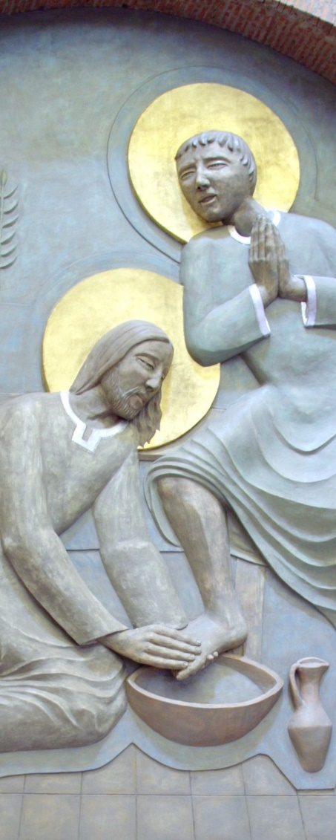
During the day we could prepare a prayer focus in the house with a bowl of water and a plate with a cup/glass. (That, again, could be an activity if there are children in the house).

In the evening at table, before or after the meal, there may be an opportunity to read one or more of the scripture passages suggested for the Lord’s Super liturgy. (Ex 12: 1-8, 11-14; Ps 115; 1 Cor: 11:23-26; Jn 13: 1-15).

Our grace before the evening meal could remember the call for Christians to serve others and how we long to gather again for the celebration of the Eucharist.

And finally, we could pray:

Almighty God
We receive new life
From the supper your Son gave us in the world.
May we find full contentment
In the meal we hope to share
In your eternal kingdom.
We ask this through Christ our Lord. Amen

Good Friday
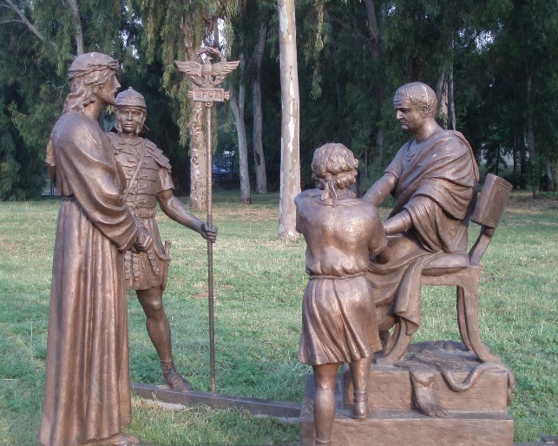
Today is an opportunity to place a Cross in a central place in our house or garden. For children, maybe they could create one from some branches that have fallen from the trees in recent winds. Through the day, as we pass the Cross, we keep in mind what Christ has done for us.

At 3pm, before the Cross we could read the Passion of the Lord: John 18: 1-19:42 (we may like to also read Is 52: 13-53:12; Ps 30; Heb. 4: 14-16, 5: 7-9).

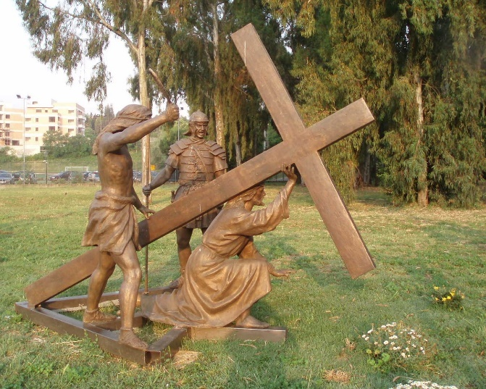
As, when we are together at Church, if there are a few people in your ‘bubble’ different people could read parts. A time to reflect could follow, if possible. The Prayers of Intercession today include prayers for: the Church, the Pope, all the faithful and clergy, all those preparing for baptism, the unity of Christians, the Jewish people, those who do not believe in Christ, those who do not believe in God, those in public office, those in tribulation, and a special prayer at this time for the sick, those who have died, and those who feel lost or dismayed.

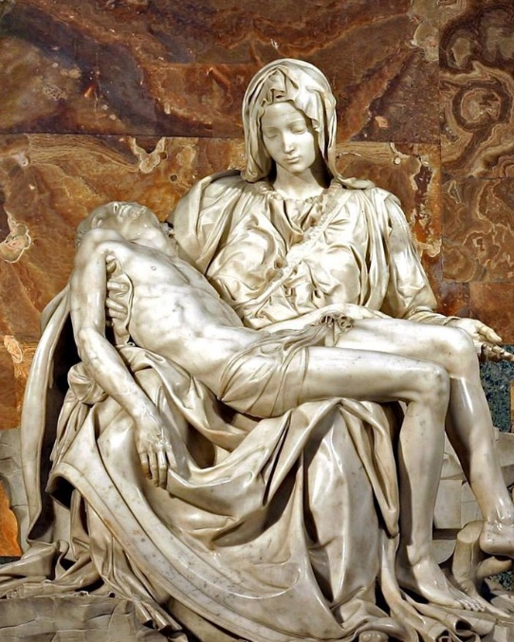
Again, this is an opportunity for children to have prepared some prayers around these themes. There could follow a time of silent prayer before the Cross. A concluding blessing could follow:

May abundant blessing, O Lord,
come down upon you people,
who have honoured the Death of your Son
in the hope of their resurrection:
may pardon come,
comfort be given,
faith increase,
and everlasting life be made secure.
Through Christ our Lord. Amen

Easter Sunday
Whether in the darkness of the Saturday evening, or in the Sunday morning light, we could gather, at the time we normally would with our parish community, in our home to rejoice in the truth that the Lord is Risen!
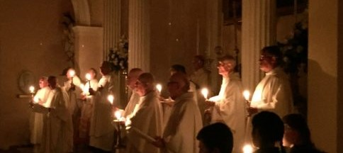
If there are children present, they could prepare for the prayer by painting a candle with bright colours and a Cross. Maybe with the numbers of the Year, 2020, at the intersection corners of the Cross. As well they could have a bowl with water and maybe some flowers around the base of the bowl.
The candle could be lit and placed beside the bowl of water. And we could pray:
O God, who on this night/day,
through your Only Begotten Son,
have conquered death and unlocked for us the path to eternity,
grant, we pray, that we who keep the day of the Lord’s Resurrection,
may, through the renewal brought by your Spirit,
rise up in the light of life.
Through our Lord Jesus Christ, you Son,
who lives and reigns for ever and ever, Amen.

There are many readings which the Church offers for reflection at this time and may be found in your Missal or online. The Gospel for the Easter Vigil is Matthew 28: 1-10, and for the Day is John 20:1-9. If children are present it could be an opportunity for them to have prepared a dramatization of the Gospel chosen. Sharing or reflection could follow on the Gospel and any other readings chosen.

Our focus could then turn to the bowl of water, and we could reflect on our own baptisms and on what we believe. The renewal of Baptismal Promises includes a rejection of Satan, his works, and all his empty promises. Then follows a profession of our faith in God, the Father Almighty, creator of heaven and earth; in Jesus Christ his only Son, our Lord, born of the Virgin Mary, who was crucified, died, was buried, rose from the dead and is now seated at the right hand of the Father; in the Holy Spirit, the holy Catholic Church, the communion of saints, the forgiveness of sins, the resurrection of the body, and life everlasting.

Prayers of the Faithful could follow remembering the needs of the faithful, the world, local communities, your family, the sick, those who have died, and special intentions for this time.

The prayer could be concluded with these or similar words:

Look upon your family, the Church, O Lord,
with unfailing love and care,
so that, renewed by this Easter celebration,
our hope may be restored
and we may come to the glory of the resurrection.
Through Christ our Lord, Amen.

HAPPY EASTER!

