# WEEK OF PRAYER FOR CHRISTIAN UNITY 2022

# Instructions for those preparing the worship

During this Week of Prayer for Christian Unity, Christians from many different traditions and confessions around the world gather to pray for the unity of the Church. This year’s materials and worship service have been prepared by the Middle East Council of Churches. The selection of scripture and liturgical texts is inspired by the visit of the Magi to the new-born King, as described in Matthew 2:1-12, particularly verse 2: “We saw his star in the East, and we came to worship him.”

Some suggested music is attached. If Christians from the Middle East are present in the congregation, it would be desirable to invite them to lead the singing of some of these hymns and chants in their own languages. Since the use of digital resources for worship has grown in recent years, links to online video recordings of some of the music have also been included.

Depending on your local context, appropriate hymns and songs that highlight this year’s theme can be substituted.

Several items should be prepared for the part of the service entitled ‘Sharing Christ’s Light’. First, a piece of dark blue cloth to be strategically hung to evoke the night sky. Second, a large star which will be hung on the cloth. Third, small paper stars for the worshippers. Depending on the context, all of those present may be invited to take a star and hang it on the ‘sky’, as an offering to the heavenly king. Alternatively, representatives can be selected to do so on behalf of the various groups and communions participating in the worship.

Parts of the service assigned to a Reader may be shared among several different readers. Similarly, texts assigned to the Leader may be shared among clergy or leaders from the different traditions and communions participating in the worship. These leaders may pronounce the Sending and Blessing together.

**Music**

The following hymns have been suggested by the Middle East Council of Churches, which prepared of the Week of Prayer for Christian Unity 2022, and are published under its responsibility. Local hymns can be substituted. The videos of hymns which are not in English can also be used for reflection.

***O Worship the King***

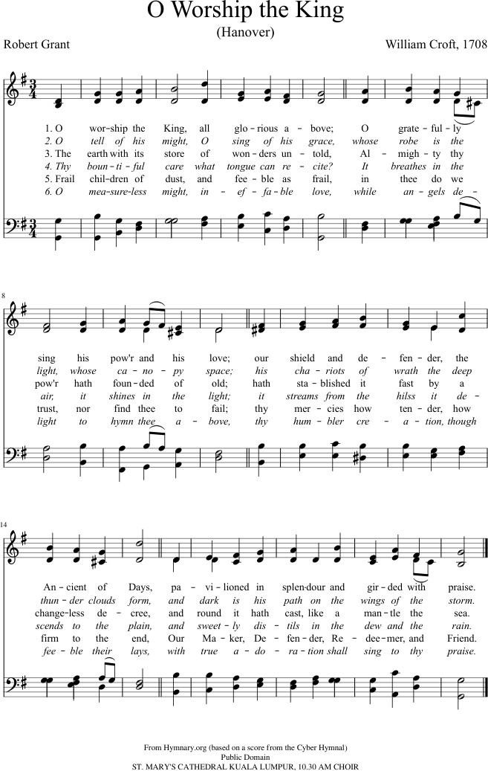<https://www.youtube.com/watch?v=RAyKmYD2Zg8>; <https://www.youtube.com/watch?v=uI9cDJMsn14>

***Song of Light (St Ephrem)***

<https://www.youtube.com/watch?v=w0A1NVTLirM&t=53s>; <https://www.youtube.com/watch?v=w0A1NVTLirM>

<https://www.youtube.com/watch?v=eyXcJmuxzm0>; <https://www.youtube.com/watch?v=oTcsS-CBEa8>

*English translation*

*Song of Light (Saint Ephrem)*

The Light of the just and joy of the upright is Christ Jesus our Lord. Begotten of the Father, he manifested himself to us.

He came to rescue us from darkness

and to fill us with the radiance of his light.

Day is dawning upon us; the power of darkness is fading away.

From the true Light there arises for us

the light which illumines our darkened eyes.

His glory shines upon the world

and enlightens the very depths of the abyss.

Death is annihilated, night has vanished, and the gates of Sheol are broken. Creatures lying in darkness from ancient times are clothed in light.

The dead arise from the dust and sing because they have a Saviour. He brings salvation and grants us life.

He ascends to his Father on high.

He will return in glorious splendour

and shed his light on those gazing upon him.

***Taize Chant: Tu amoris ignem***

<https://www.youtube.com/watch?v=IbUjKaaI0rE> (Aramaic version);

***Chant: Trisagion***

In English: <https://www.youtube.com/watch?v=-lzQcSzirJg>

In English and Greek: <https://www.youtube.com/watch?v=oJ6of7ViJ5w>

***We Three Kings of the Orient Are***

<https://www.youtube.com/watch?v=j1ZOGTPsxng>

<https://www.youtube.com/watch?v=Lx35_DRIZ8g>

***Lord the Light of you Love (Shine Jesus Shine)***

<https://www.youtube.com/watch?v=rce9UHYZwl4>

***Coptic Hymn***

<https://www.youtube.com/watch?v=93_cM9FwSe8&feature=youtu.be&fbclid=IwA> [R1YUA_ a0yTKpJ7WQCnjogpvNgXAwkO4E-](https://www.youtube.com/watch?v=93_cM9FwSe8&feature=youtu.be&fbclid=IwAR1YUA_a0yTKpJ7WQCnjogpvNgXAwkO4E-M5dWXnoovWwHbNiESCwJgYZN8) [M5dWXnoovWwHbNiESCwJgYZN8](https://www.youtube.com/watch?v=93_cM9FwSe8&feature=youtu.be&fbclid=IwAR1YUA_a0yTKpJ7WQCnjogpvNgXAwkO4E-M5dWXnoovWwHbNiESCwJgYZN8)

Our Lord, our Lord

Our Lord, our Lord, came for us our Lord. born in the manger like us because He truly loves us.

Refrain: He loves all of us; He redeemed all of our souls. (2)

Our Lord, our Lord, came for us our Lord. (2) I am glad, I am glad; by your birth, O my Lord, your birth in Bethlehem a great joy to my soul.

Our Lord, our Lord, came for us our Lord. (2) The virgin rejoiced in the word of Gabriel, our hearts are happy in the birth of Emmanuel.

Our Lord, our Lord, came for us our Lord. (2) In the east was a star shone to the wise men. Our hearts are candles lit to the Holy Lord.

Our Lord, our Lord, came for us our Lord. (2) The angels in the sky praised the Lord for His birth. Glory to God in the highest and peace be on earth.

Our Lord, our Lord, came for us our Lord (2)