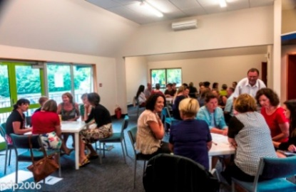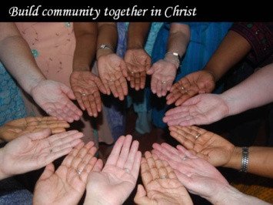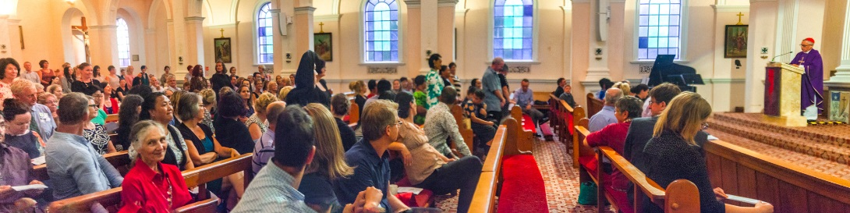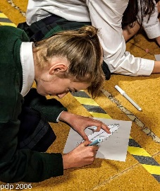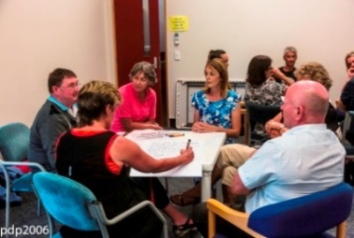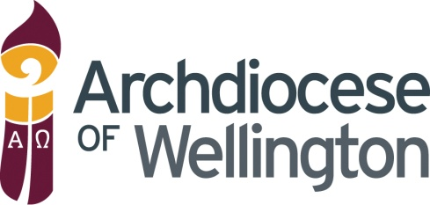Board

**Other RE Qualifications**

*The Tertiary Catholic Institute and Good Shepherd College have merged and from 2020 will be known as the: -*

***Catholic Theological College***

As well as short courses, the Catholic Theological College offers formal qualifications in Religious Education through the *‘Certificate in Christian Studies’* and the *‘Diploma in Christian Studies*’, both with a focus on Religious Education.

The study consists of papers in Theology, Scripture and Religious Education. At the diploma level, there is a choice of which particular courses are studied. This would be considered the minimum qualification that a specialist teacher of Religious Education would be working towards.

For more information and further study options offered by the Catholic Theological College go to:

[www.ctc.ac.nz](http:// www.ctc.ac.nz)

or

contact the CSES Coordinator,

Ilana de Ras, Phone: (04) 496 5184

Email: [i.deras@wn.catholic.nz](mailto:i.deras@wn.catholic.nz)

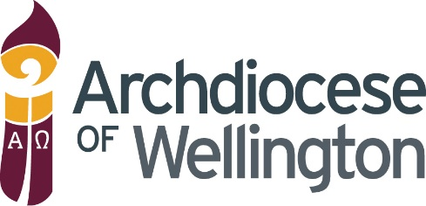

*“Act justly, love tenderly and walk*

*humbly with your God”*

Micah 6:8

Board Leadership

**Professional Development**

**for 2023**

**Catholic Schools**

**Education Services**

To provide assistance and support in all aspects of Catholic Education throughout the Archdiocese of Wellington

*Printed December 2022*

# 

**Catholic Schools Education Services**

Catholic Centre

204 Thorndon Quay

Wellington 6140

Phone: (04) 496 1710



**To register for professional development:**

Please email: [cses@wn.catholic.org.nz](mailto:cses@wn.catholic.org.nz)

with course name/date of course/  
Attendee’s Name(s)

**or for more information contact**

Marian Blackford, Administrator for CSES

(04) 496 1710

[m.blackford@wn.catholic.org.nz](mailto:m.blackford@wn.catholic.org.nz)

|  |  |  |  |
| --- | --- | --- | --- |
|  | **To Register Click on Register link OR please email:** [**cses@wn.catholic.org.nz**](mailto:cses@wn.catholic.org.nz)  **with your name, course name & course date.** | | |
| **Jan** | **Governance & Integration**  *Responsibilities of the Board in a Catholic State Integrated School. What is Governance versus Management?*  When: Tuesday 31 January, 1730 Where: FL 2/204 Thorndon Quay [Click to Register](https://forms.gle/oyw1bhJjWvDhExav9)  **Cost: $15** | | |
| **Feb** | **Governance & Integration**  *Responsibilities of the Board in a Catholic State Integrated School. What is Governance versus Management?*  When: Thursday 2 February, 1730 Meeting ID: ZOOM [Click to Register **Cost: Nil**](https://forms.gle/GSCNVcwHaMcCRgAM8%20%20%20%20%20%20%20%20%20%20%20%20%20%20%20%20%20%20%20%20%20%20%20%20%20%20%20%20%20)  **Commissioning Mass**  *A community celebration for all ADW Catholic Primary & Secondary Schools Staff and Boards for Cardinal John to commission us for the new school year.* | | |
| When: **~~Tuesday 15 February~~***~~,~~* **~~173~~0 postponed** Where: **St Mary’s of the Angels, Wellington**  When: **Friday 17 February 1730** Where: **Motueka**  **Special Character**  *Responsibilities of the Board for Special Character.*  When: Tuesday 21 February, 1730 **Where: FL 2/204 Thorndon Quay** [Register **Cost: $15**](https://forms.gle/jLuGkLJi6FgaaETE9%20%20%20%20%20%20%20%20%20%20%20%20%20%20%20%20%20%20%20%20%20%20%20%20%20%20%20%20%20%20%20%20%20%20%20%20%20%20%20%20)  When Wednesday 22 February, 1730 **Where:** ZOOM [Register **Cost: Nil**](https://forms.gle/2NvPtYRLywpAGF1m6) | | |
| **Mar** | **Proprietor Appointees**  *What is the Role of the Proprietor Appointee?* | | |
| When**: Tuesday 28 March, 1730** | Where: FL 2/204 Thorndon Quay [Register **Cost: $15**](https://forms.gle/8CGs1A4GesW15Kur9) | |
| When**: Thursday 30 March, 1730** | Where: ZOOM [Register **Cost: Nil**](https://forms.gle/awTn1CkxZZKxoef68) | |
| **Apr** | **Property**  *Property is a key area of the Board’s role and responsibilities, and the requirements of integrated schools differ from those of state schools. What are the key responsibilities?* | | |
| When**: Tuesday 25 Apr, 1730** Where: FL 2/204 Thorndon Quay [Register](https://forms.gle/zeTaRCYJXvaKAPCu6) **Cost: $15**  When**: Wednesday 26 Apr, 1730** Where: **ZOOM** [**Register**](https://forms.gle/M6xZJm535yzjz2FBA)  **Cost: Nil** | | |
| **May** | **Employment**  *Appointing teaching staff to Special Catholic Character positions (CL47,CL50).* | | |
| When**: Tuesday 23 May, 1730** | Where: FL 2/204 Thorndon Quay **Cost: $15** [**Register**](https://forms.gle/9Bwbvg9BUgPigJ9b9) | |
| When**: Thursday 25 May, 1730** | **Where: ZOOM** [**Register**](https://forms.gle/9Bwbvg9BUgPigJ9b9)  **Cost: Nil** | |
| **June** | **Internal Evaluation**  *Internal Evaluation in a Catholic School.*  When: **Tuesday 20 June, 1730** Where**: FL 2/204 Thorndon Quay** [**Register**](https://forms.gle/7in338oc2KMhK5Wd9) **Cost: $15**  **When: Thursday 22 June, 1730 Where: ZOOM** [**Register**](https://forms.gle/J9bjUnFxQTWvUWx48) **Cost: Nil** | | |
| **July** | **Professional Growth Cycles**  *A look at Professional Growth Cycles from a Catholic perspective.*  When: Tuesday 18 July, 1730 Where: FL 2/204 Thorndon Quay [Register](https://forms.gle/zNmLYAr9wsjieL8U9) **Cost: $15**  When: Thursday 20 July, 1530 Where: ZOOM [Register](https://forms.gle/Gb9kvwvPeWGFJnQb6)  **Cost: Nil** | | |
| **Aug** | **Enrolment/Schemes**  *A look at Board responsibilities regarding enrolments.*  When: Tuesday 22 August Where: FL 2/204 Thorndon Quay [Register](https://forms.gle/bdqPZKFv7EvGSJiQ7) **Cost: $15**  **When: Thursday 24 August Where: ZOOM Cost: Nil** [**Register**](https://forms.gle/4aSfxdsiSsTA3Hiz7) | | |
|  | | |
| **Sep** | **Compliance**  *What are the Board’s compliance responsibilities?* | | |
| When**: Tuesday 19 September, 1730** | Where: FL 2/204 Thorndon Quay **Cost: $15** [**Register**](https://forms.gle/dMnw2SQD9BhNrXwS8) | |
| When**: Thursday 21 September, 1730** | Where: ZOOM [Register](https://forms.gle/eoPt7m7LVKsZkVZp9)  **Cost: Nil** | |
| **Oct** | **Board Workshop - FL 2/204 Thorndon Quay** | | |
|  |  | |
|  |  | |
| **Nov** | **Board Workshop - FL 2/204 Thorndon Quay** | | |
|  | |  |
|  | |  |
| **Board Workshop - FL 2/204 Thorndon Quay** | | |
|  |  | |
|  | **Any professional development needs that are identified or requested will be responded to with the addition of Professional Development sessions.**  Register by clicking on The Register link for each course. (ctrl and click)  **Professional Development and Support is also offered on a needs basis for boards individually.**  Book this support in at your convenience with Marian, (04) 496 1710 or [m.blackford@wn.catholic.org.nz](mailto:m.blackford@wn.catholic.org.nz) | | |