**Catholic Special Character Evaluation for Development**

**INTERNAL EVALUATION**

**YEAR: _____________**

**DIMENSION: __________________________________________________________________________________________________________________________________**

**FOCUS AREA: __________________________________________________________________________________________________________________________________**

**CONTEXT FOR IMPROVEMENT: ______________________________________________________________________________________________________________________________________________________________________________________________________________________________________________________________________________________________________________________________________________________________________________________________________**

**MODELS OF INQUIRY: __________________________________________________**

**PURPOSE:**

1. *To demonstrate how you (Principal, Board, DRS + College community) are safeguarding and strengthening Catholic Special Character at your school?*
2. *To provide assurance to the proprietor and the community that your school is authentically Catholic and are meeting the goals of Catholic Education?*

**EXAMPLES OF CONTEXTS FOR IMPROVEMENT**

**Example One**

➢ XXXX college/school board has recently set up a four-year cycle for the internal evaluation of Catholic special character. This year they will begin with **Dimension 1: Te Tūtaki ki a Te Karaiti: Encounter with Christ** described in the Catholic Special Character Evaluation for Development in Catholic State Integrated Schools, Aotearoa New Zealand (2022) document (page 13-17).

➢ The principal has suggested the board concentrates the evaluation on the **Spiritual Formation Focus Area** after recent conversations in a Catholic Special Character staff meeting suggested that teachers feel they are not always confident in articulating the meaning and purpose of the school’s charism. (Noticing Stage)

➢ The board and principal decide to examine what is causing this and what the solutions could be so that there are better outcomes for learners. (Noticing Stage)

See **Template Example One** to follow how the college/school could use the Ministry of Education: ERO internal evaluation model.

**Example Two**

➢ This will be the second time the college/school have evaluated **Dimension 2: Mā te Mātauranga ka Tipu-Growth in Knowledge Growth**. Last time they evaluated the Leadership Focus Area this time it will be the **Religious Education Focus Area**.

➢ In their discussions the board identifies that the last external Catholic special character review for development recommended the Religious Education systems and processes needed strengthening particularly in the areas of assessment and evaluation. The board delegates to the leadership team including Principal and DRS to take a closer look at what is occurring (this could be in either Years 1-8 for a Primary or 9 & 10 for Secondary). (Noticing Stage)

See **Template Example Two** to follow how the college/school could use the Ministry of Education: ERO internal evaluation model.

**Example Three**

➢ The diocesan Catholic education office has set **Dimension 4: Safeguarding and Strengthening Catholic Special Character** as this year’s dimension for internal Catholic special character evaluation.

➢ Last time this dimension was internally reviewed the **Stewardship: Employment** focus area was the emphasis, this year it will be **Stewardship: Professional Development**.

➢ During board discussions on how to make this manageable they work to narrow their focus. Several board members remind the board the last Catholic special character review report recommends that the board engage in ongoing Catholic special character professional learning and formation (PLF). (Noticing Stage)

➢ The board decides to examine what Catholic special character PLF they have engaged in and what could be the basis of a three-year plan. (Noticing Stage)

See **Template Example Three** to follow how the board could use the Ministry of education: ERO internal evaluation model.

**MODELS OF INQUIRY:**

***Which model of inquiry did you choose for your Internal Evaluation and Why?***

**MODEL 1: ERO and MoE**

**EFFECTIVE SCHOOL EVALUATION:**

Education Review Office and Ministry of Education (2016)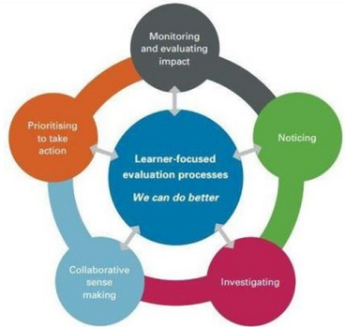

***How to do and use evaluation for improvement.*** This model aims to assist Boards, leaders and teachers to engage in deliberate, systematic processes and reasoning with improved outcomes for all students.

**Those involved collaborate to:**

• *Investigate and scrutinise practice*

*• Analyse data and use it to identify priorities for improvement*

*• Monitor implementation of improvement actions and evaluate their impact*

*• Generate timely information about progress towards goals and the impact of actions.*

**The inquiry model follows five interconnected processes:**

**1. Noticing**

**2. Investigating**

**3. Collaborative sense making**

**4. Prioritising to take action**

**5. Monitoring and evaluating impact.**

This model is aimed at Boards, Leaders and Teachers.

**MODEL 2: Timberley et al.,**

**INNOVATION & THE SPIRAL OF INQUIRY.**

Timberley, H., Kaser, L. & Halbert, J. (2014).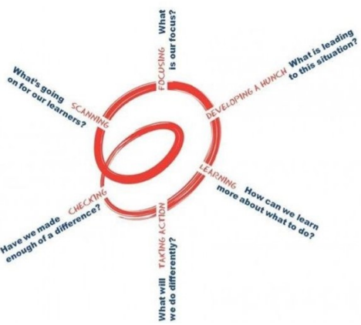

**Effective School Evaluation:** The focus of this model is on both student voice and agency. It also calls for professional collective agency across the school.

It encourages a mindset of curiosity and genuine inquiry into what is going on for students and to move on from there: it is ‘a spiral of ongoing inquiry, learning and action’ (p.6).

The spiral of inquiry is an ongoing-overlapping and interconnected process. The evidence seeking is focused on two questions:

**1. What is going on for ākonga?**

**2. How do we know?**

**Following the inquiry process**:

• Identified next steps from the internal inquiry/ evaluation should go into the school’s strategic and annual plan for action.

• Those who participated should be informed of the outcome-they need to know that their voice has been heard and the planned changes.

This model involves the students, their whānau and the community.

**Evaluating the Catholic Character of our Schools**

For each dimension there are:

* **Focus areas**
* **Possible inputs** (ways in which the Schools can showcase how they are focusing on this dimension)
* **Possible outcomes** (ways in which the College can ascertain that there is growth in the faith journey related to the focus area)
* ***This is NOT a checklist, but a guide*** (p.12-27 of the Document)
* The Internal Evaluation is a chance for Schools to highlight successes and opportunities for improvement in their communities.
* The expectation for the size of the Internal Evaluation is approx. 2 pages.
* It is submitted to **Kelly Ross** (Vicar for Catholic Education) at the end of each year. [k.ross@wn.catholic.org.nz](mailto:k.ross@wn.catholic.org.nz)

**Useful Websites**

New Zealand Catholic Education Office

<https://www.nzceo.org.nz/>

Catholic Special Character Evaluation for Development Document

<https://www.nzceo.org.nz/wp-content/uploads/2022/02/January-2022-version-Catholic-Spch-evaluation-document.pdf>

Resources

<https://www.nzceo.org.nz/resources-2/>

Special Character Resources

<https://www.nzceo.org.nz/resources-2/#special-character>

Introduction to the Internal Template:

<https://www.nzceo.org.nz/wp-content/uploads/2022/06/Introduction-to-Catholic-Special-Character-Internal-Evaluation-Template.pdf>

Internal Evaluation Template Example 1:

<https://www.nzceo.org.nz/wp-content/uploads/2022/06/Catholic-Special-Character-Internal-Evaluation-Template-Example-One.pdf>

Internal Evaluation Template Example 2:

<https://www.nzceo.org.nz/wp-content/uploads/2022/06/Catholic-Special-Character-Internal-Evaluation-Template-Example-two.pdf>

Internal Evaluation Template Example 3:

<https://www.nzceo.org.nz/wp-content/uploads/2022/06/Catholic-Special-Character-Internal-Evaluation-Template-Example-three.pdf>

Internal Evaluation Blank Template:

<https://www.nzceo.org.nz/wp-content/uploads/2022/06/Catholic-Special-Character-Internal-Evaluation-Template-Blank-Final.docx>