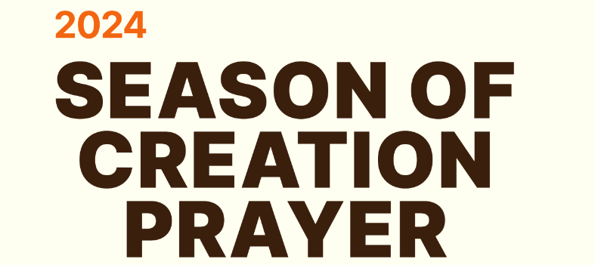

Kia ora

This resource letter has been collated by the Integral Ecology (IE) Committee of the Ecology Justice and Peace Commission (EJP) for the Archdiocese of Wellington. It is hoped that the contents of the pack will support your Parish and Communities to celebrate the Season of Creation (SOC) 1st September to 4th October. Please share, collaborate and pass it on to others who will help. Go to the EJP Commission Website to keep up with what is happening regarding Activities of the following committees: Integral Ecology, Bicultural Relations and Poverty

<https://www.wn.catholic.org.nz/about/commission-for-ecology/ejp-commission-activities/>

The official global SOC website with a wealth of resources and online events:

<https://seasonofcreation.org/resources/> Explore all the resource tabs and scroll down for more. In Liturgical Resources find the LSM Prayer Book / Stations of Creation – inspired by the Via Crucis format

For more Resources see [www.humandevelopment.va](http://www.humandevelopment.va)

Sisters of St Joseph Laudato Si Action Plan [https://www.sosj.org.au/laudato-si-action-plan/](https://www.sosj.org.au/laudato-si-action-plan/soft-plastics-campaign-2023/)

The Wellbeing Economy Alliance Aotearoa <https://www.weall.org.nz/>

Rich Living Series - A Rocha Resources: Waste, Water, Climate Change, Transport, Food available to order at <https://arocha.org.nz/rich-living-series/>

101 Ways To Care For The Earth – Activities for Children (US based but can be adapted)

<https://nepis.epa.gov/Exe/ZyPURL.cgi?Dockey=9101X61O.txt>

**Suggestions for your parish community**

1. Display in your worship space the theme SeasonofCreation.org. for 2024 above.
2. See Guidebook for Season of Creation Addendum 2 & 3 for ideas and Activities.
3. Have children grow seeds or do a seed swap for the SOC
4. Place the Prayer card and a copy of *Laudato Si'* on display. Say the prayer for SOC 2024 together at weekday Masses or create a PowerPoint of the Prayer

**Contents attached to this email**

* Introduction Letter with Links to helpful websites
* Season of Creation Prayer Card / Pope’s Prayer Intention
* Prayer of the Faithful suggestions for your liturgies during the Season of Creation
* Quotes and Actions for Newsletters for duration of Season of Creation
* Message for the World Day of Prayer for the Care of Creation Infographic
* Live Simply Alphabet / Do I Need It Cards (adjusted)
* Season of Creation Calendar (Mercy International Association)
* Stations of the Cross for Care of Creation (Adapted by Ōtari Parish)
* Via Creationis - the way of creation/ Via Creationis Participants

The IE Committee is happy to answer any queries. Please don’t hesitate to contact me Estelle Henrys [ev.henrys@gmail.com](mailto:ev.henrys@gmail.com) Lastly, we would love you to share any events you are planning during the SOC to give people ideas and inspiration for our ongoing actions for Care of our Common Home. We can put them on our Website and Facebook Page to highlight this vital time in our church calendar. Ngā mihi

Estelle Henrys (Convenor Integral Ecology Committee)